[www.kktutorials.com](http://www.kktutorials.com)

Youtube Link : https://www.youtube.com/watch?v=QunBtnwYMhU&list=PLzS3AYzXBoj8E3NjjWNjrrFjyexXIyZbL

Part – 1

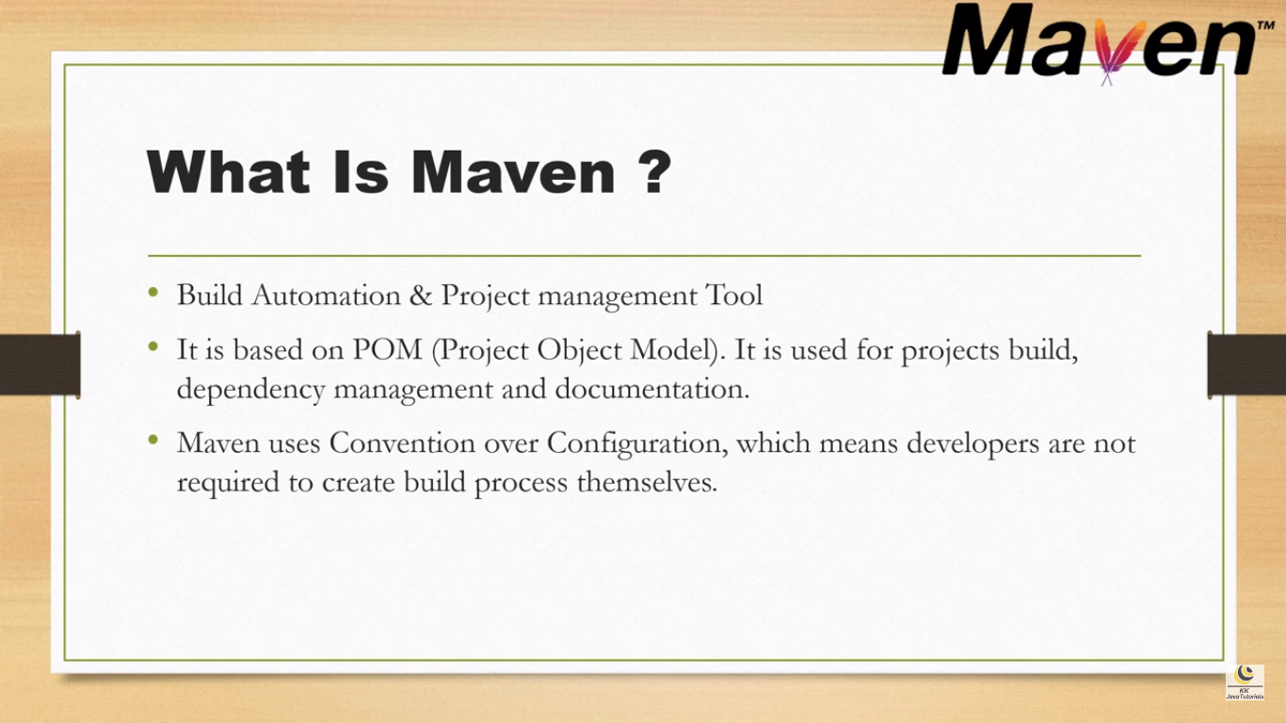

Part – 2

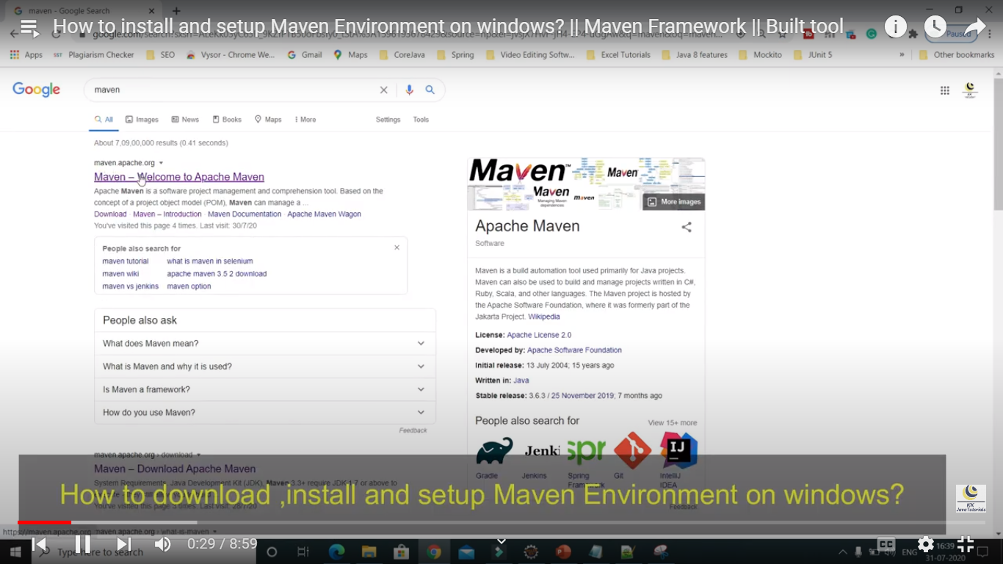

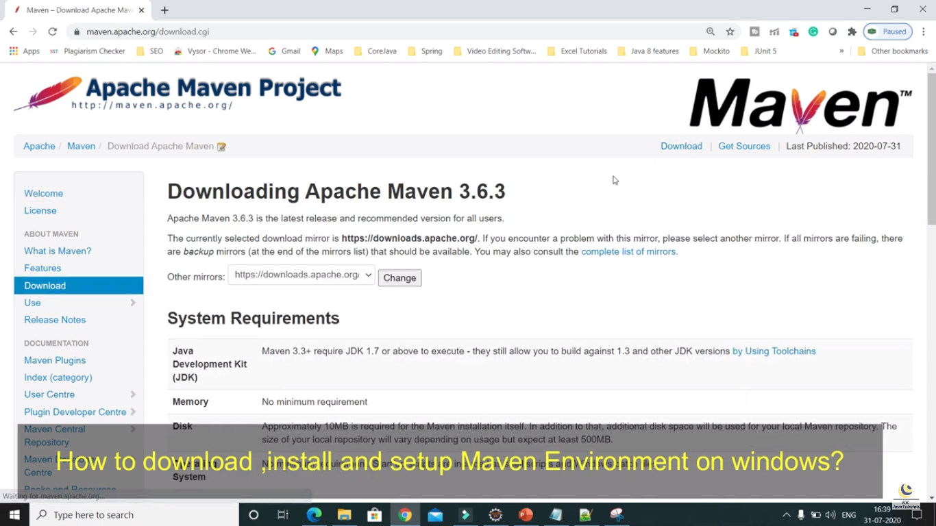

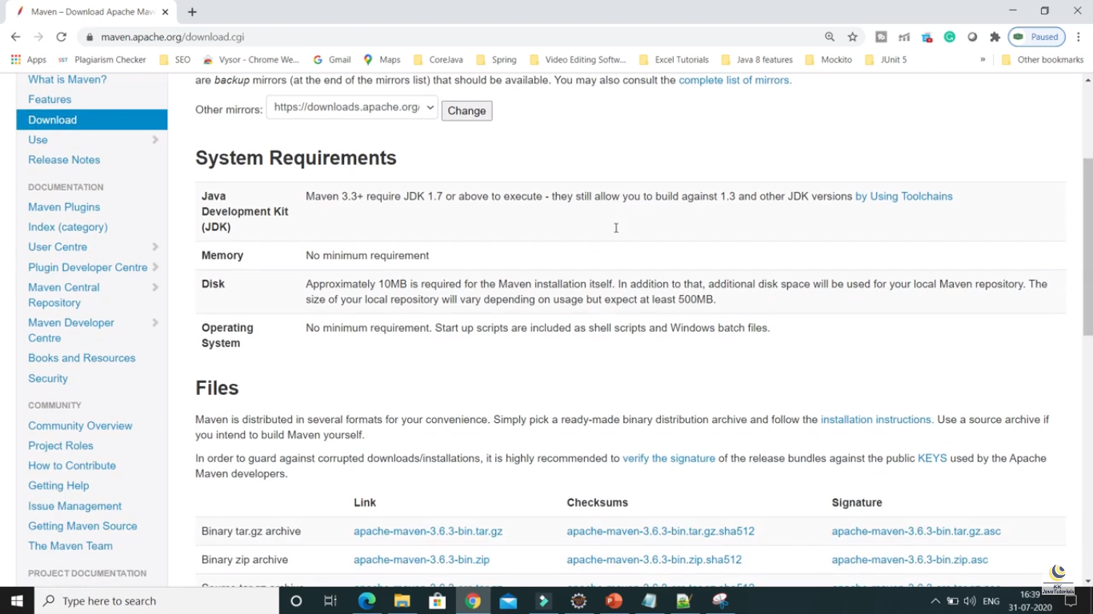

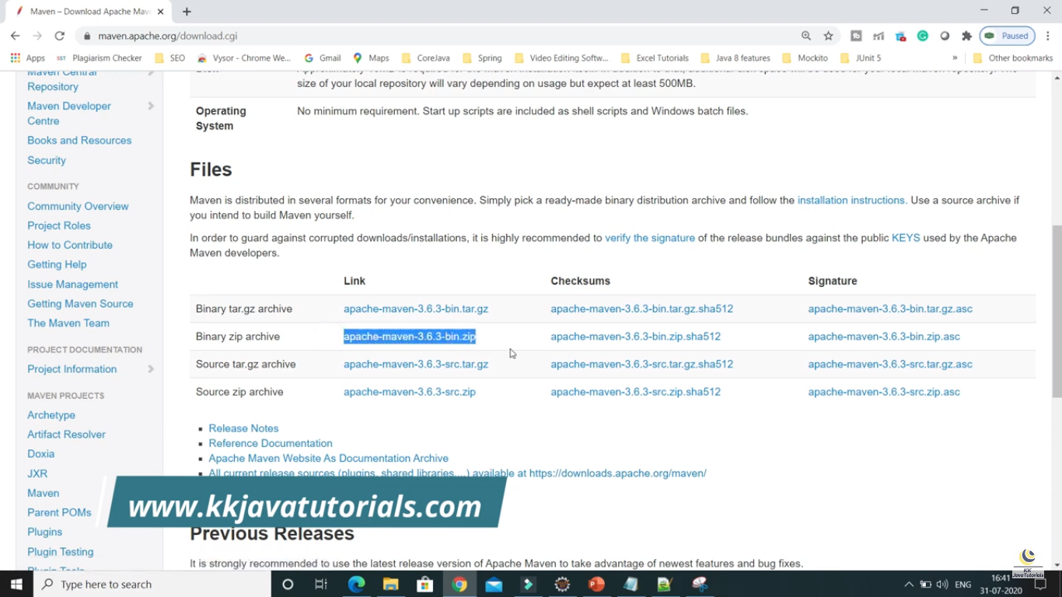

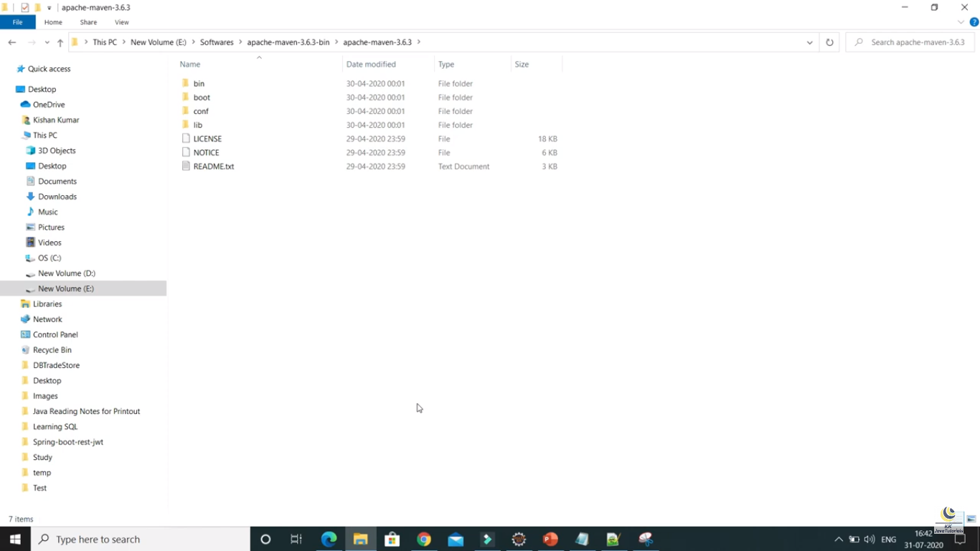

Configure maven in environment variables

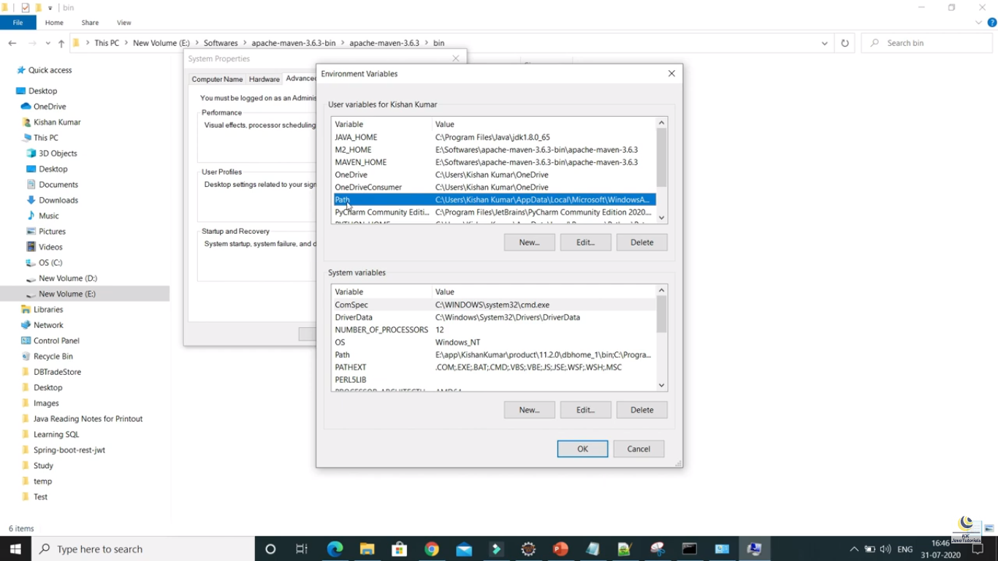

Set the bin path in path variable as below

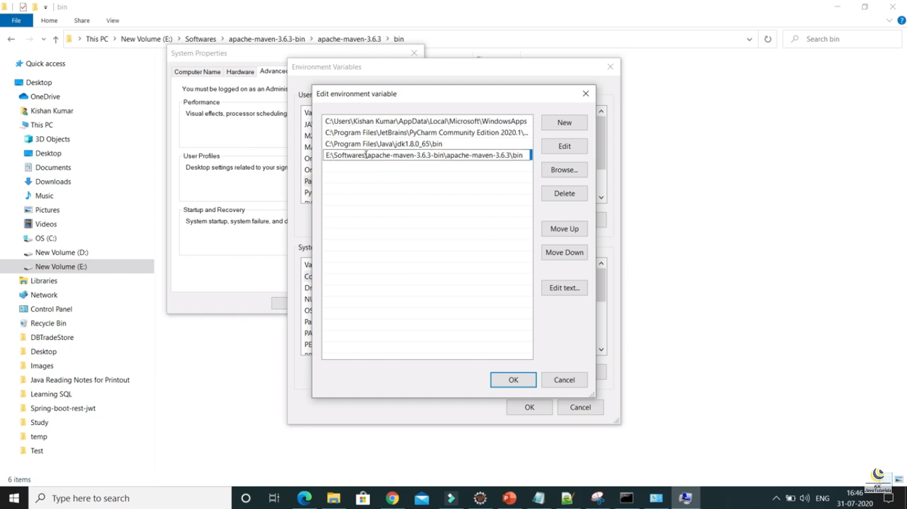

Part – 3:

**Create Maven Project Using command prompt**

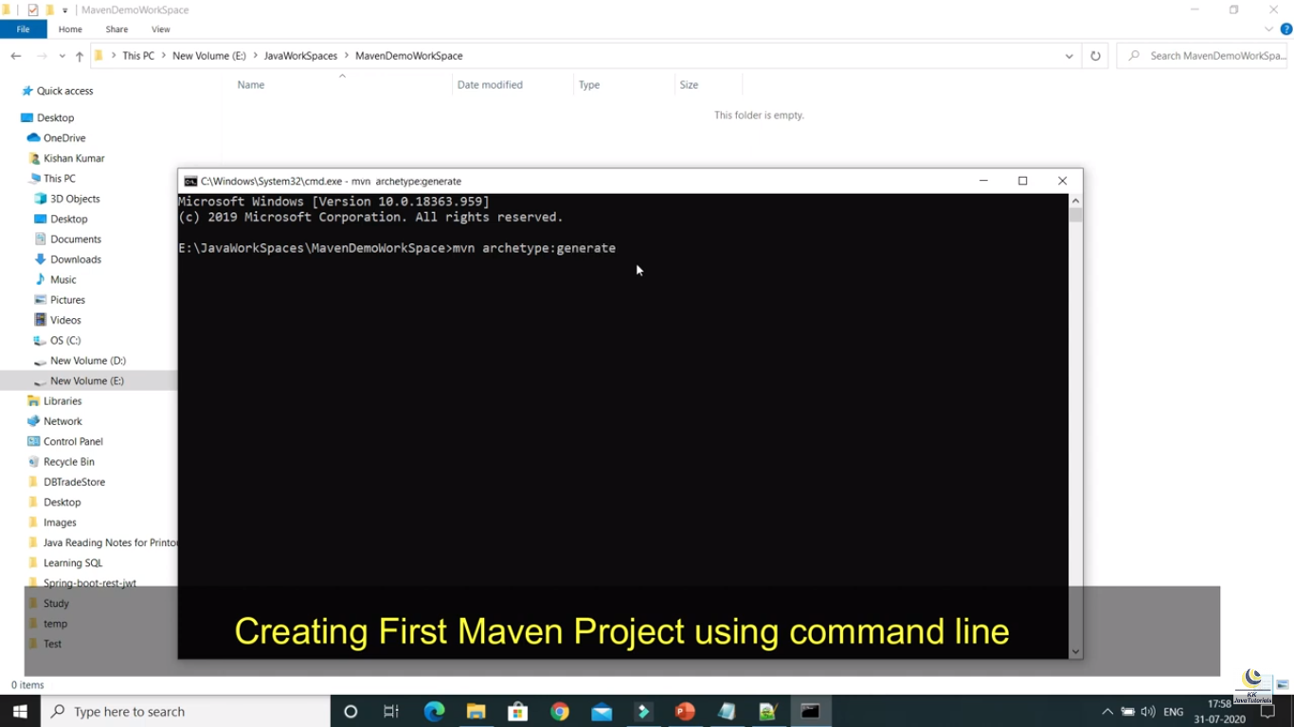

The above command ‘mvn archetype:generate’ will generate the project by selecting the different types

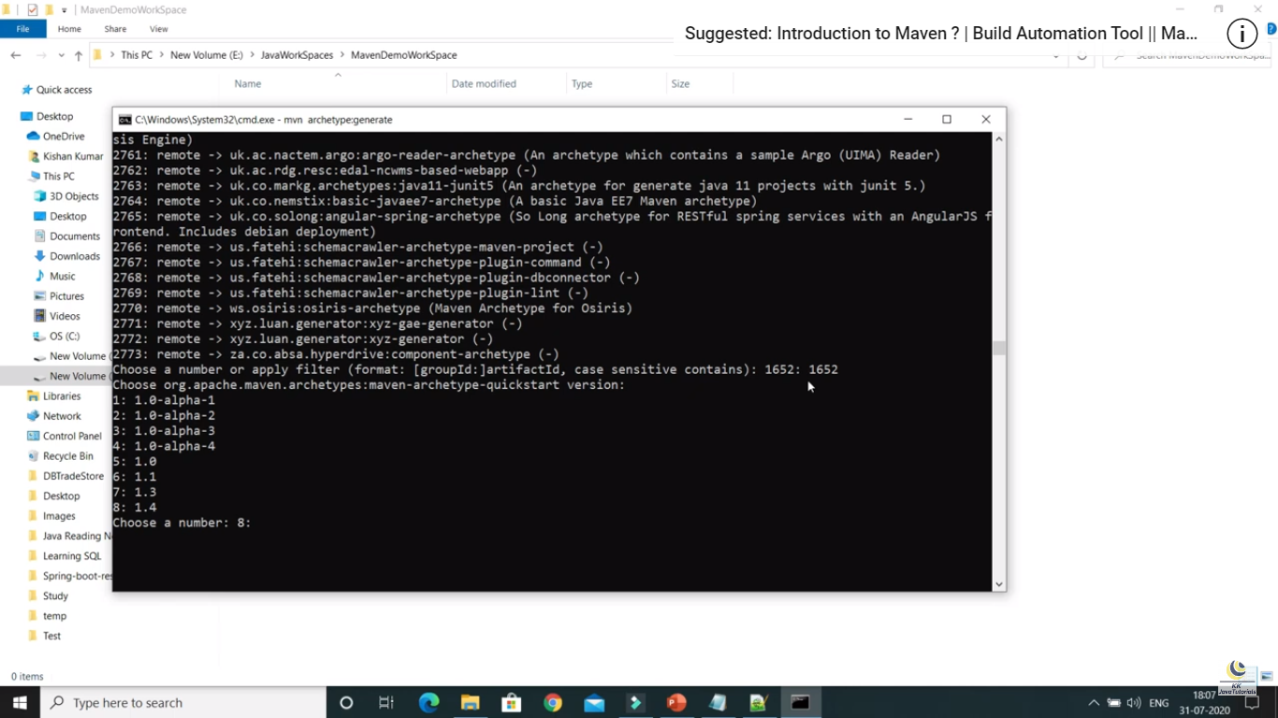

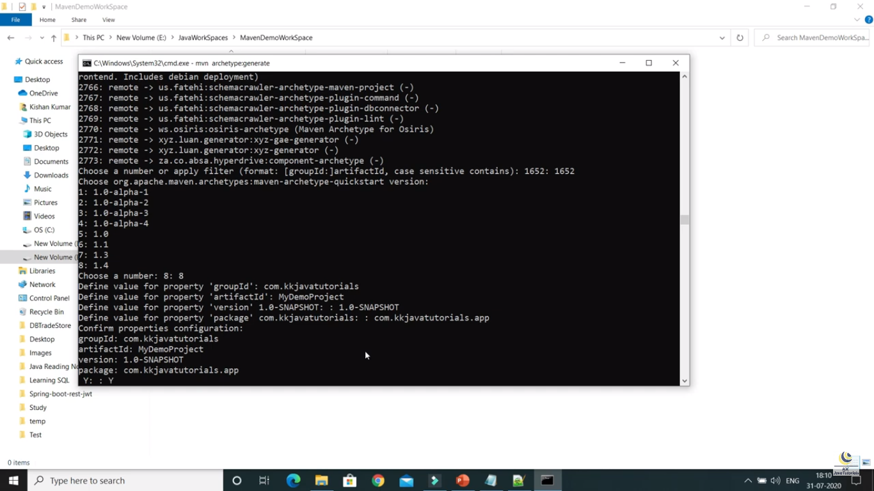

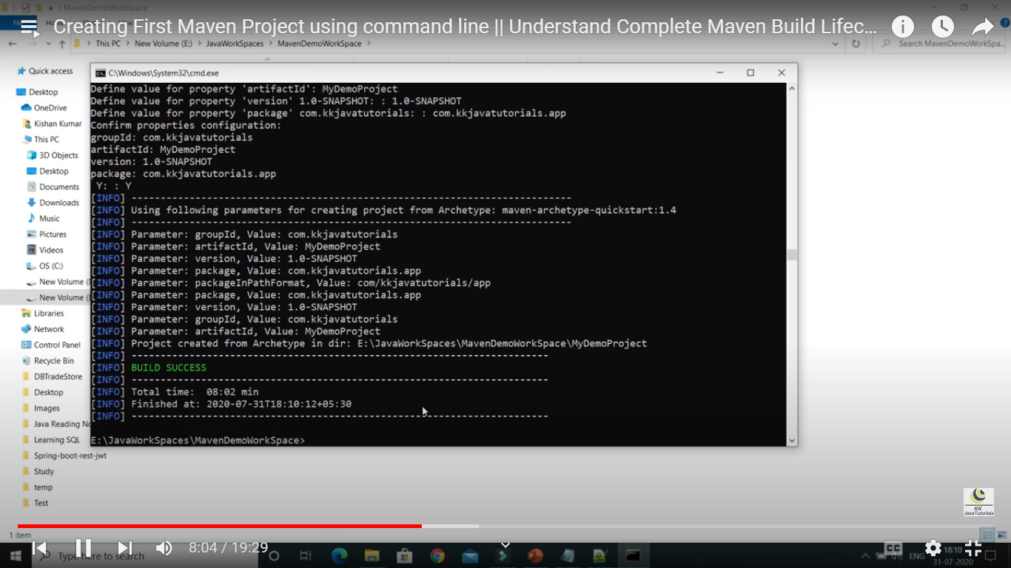

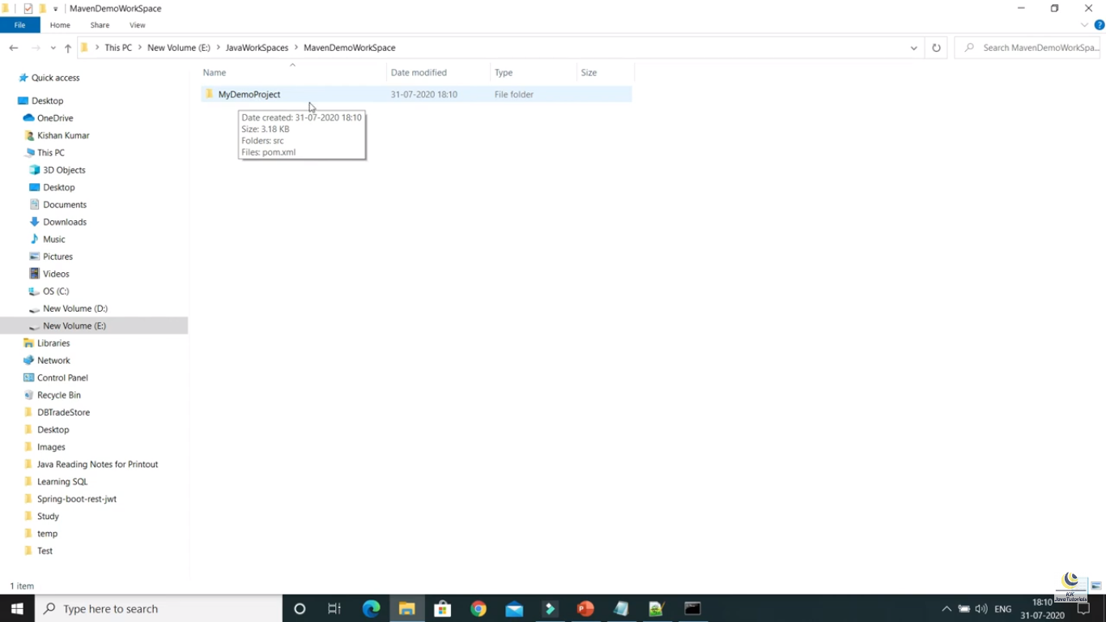

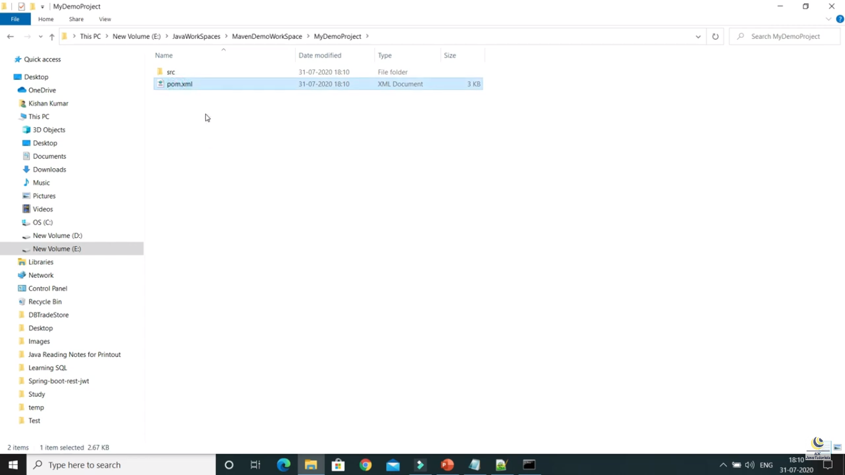



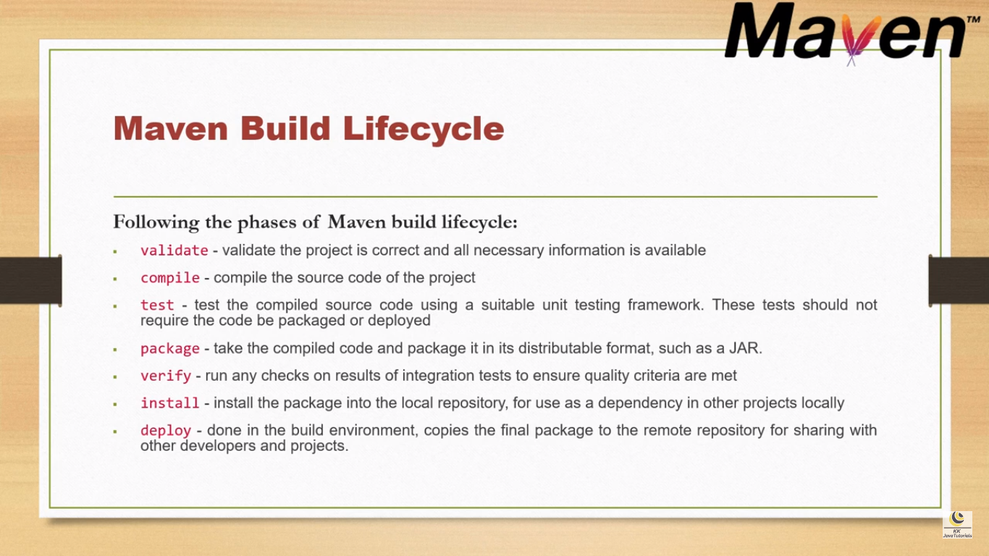

Note : If I run ‘mvn package’ command then automatically the previous commands will run internally. In the same way the other commands also will run.

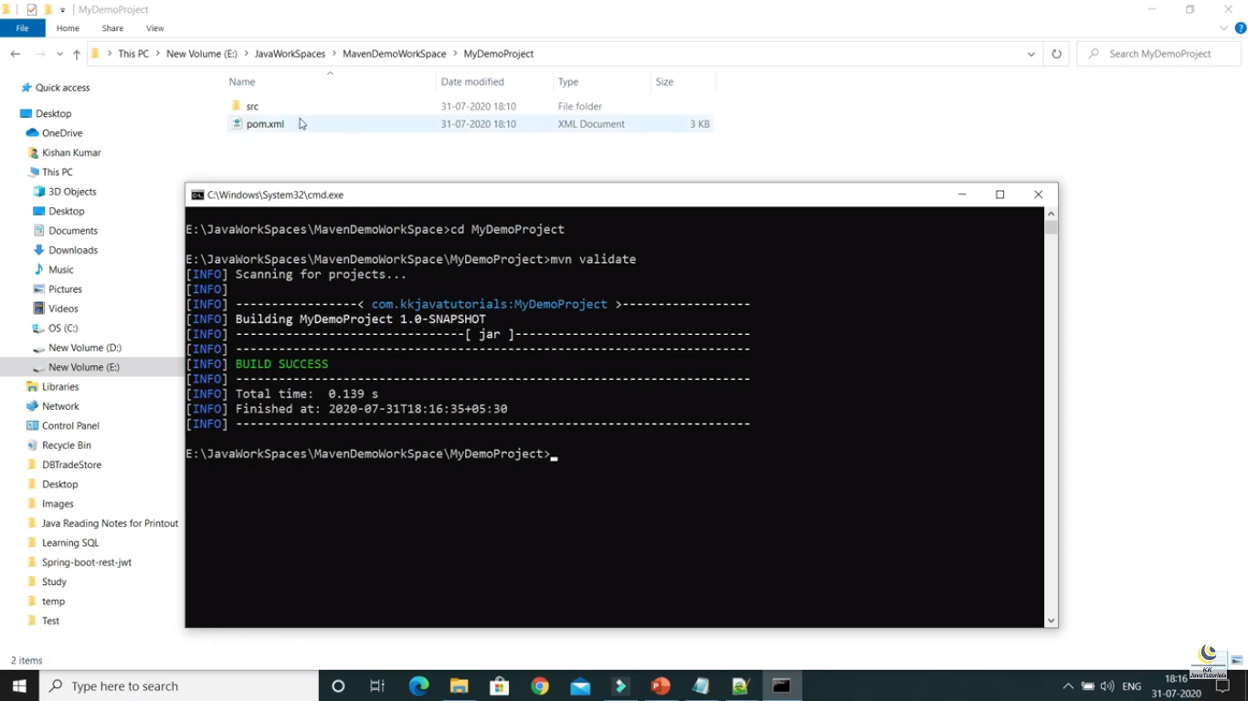

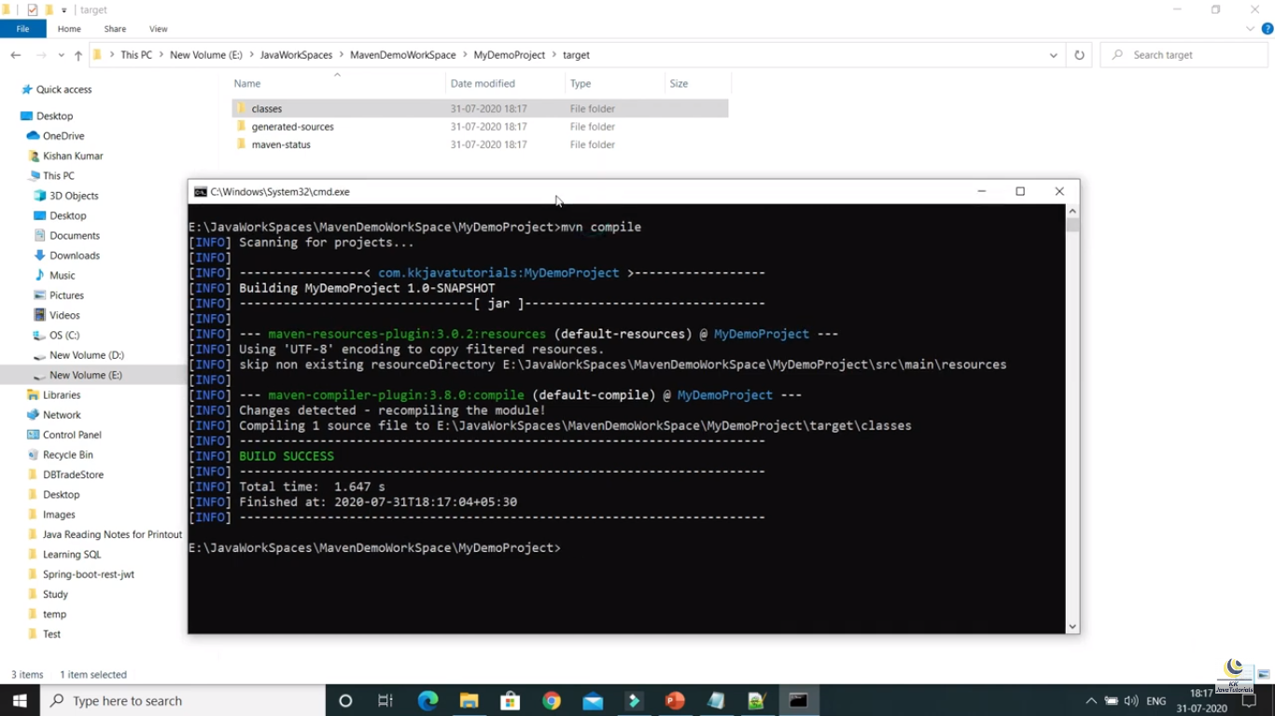

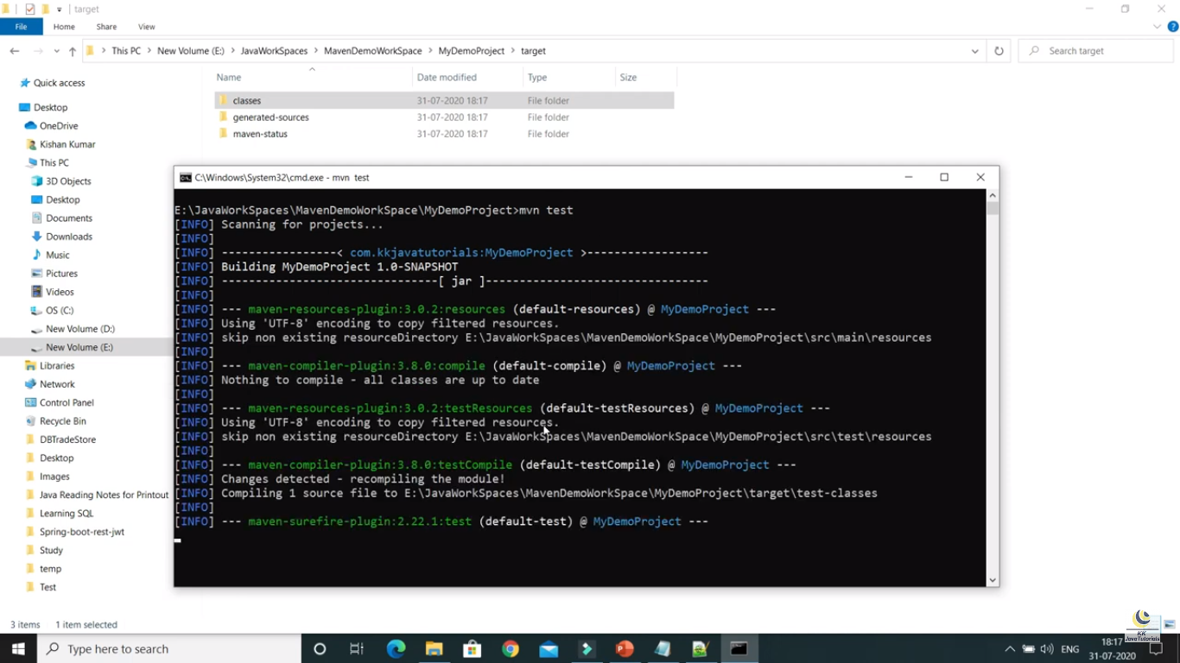

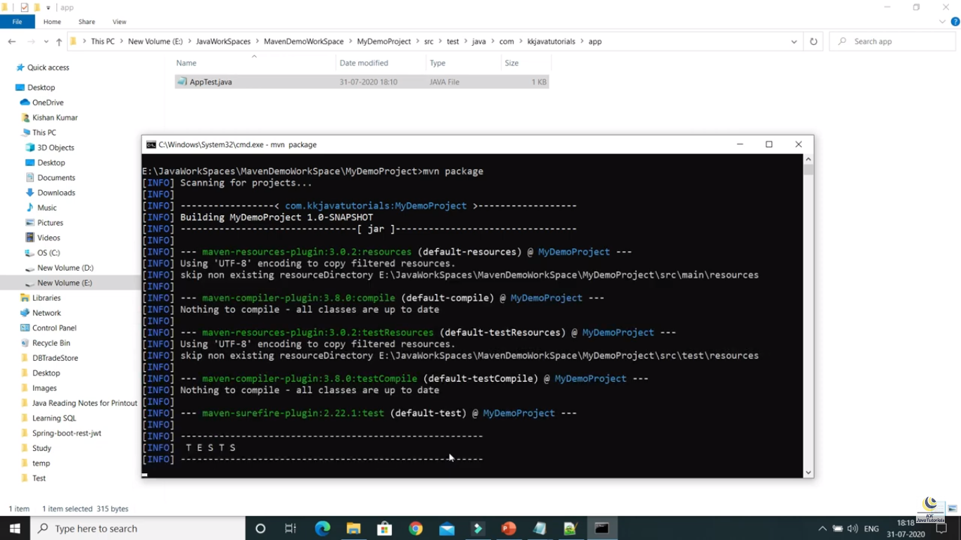

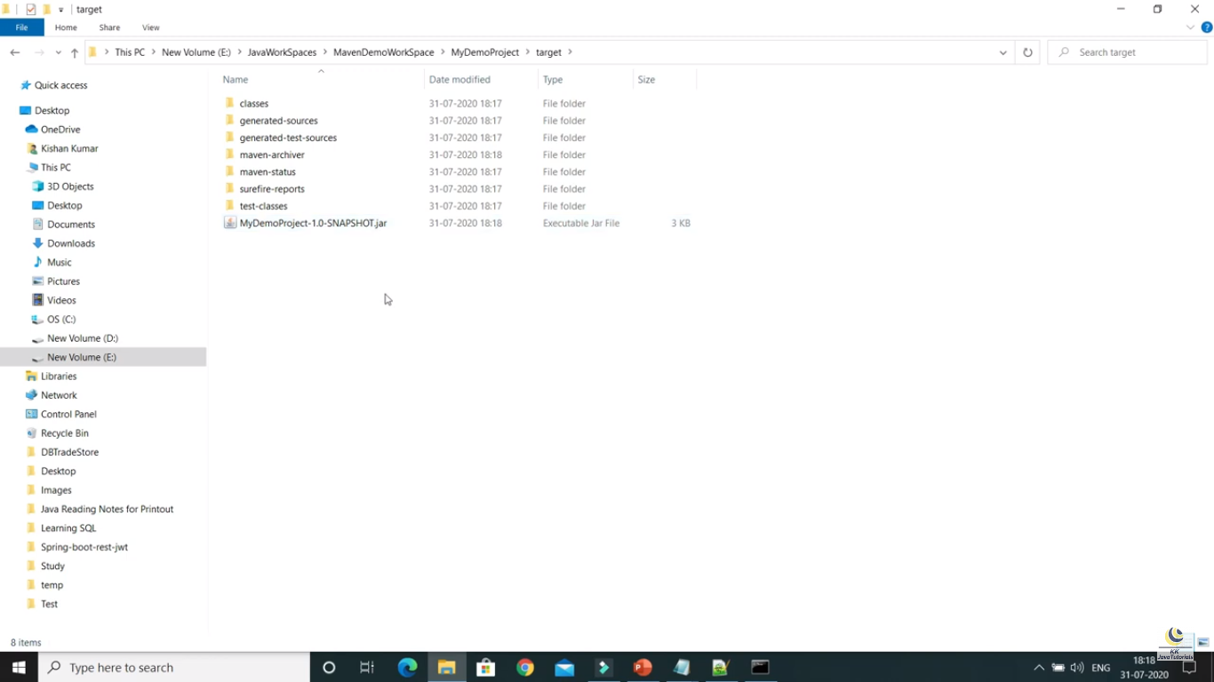

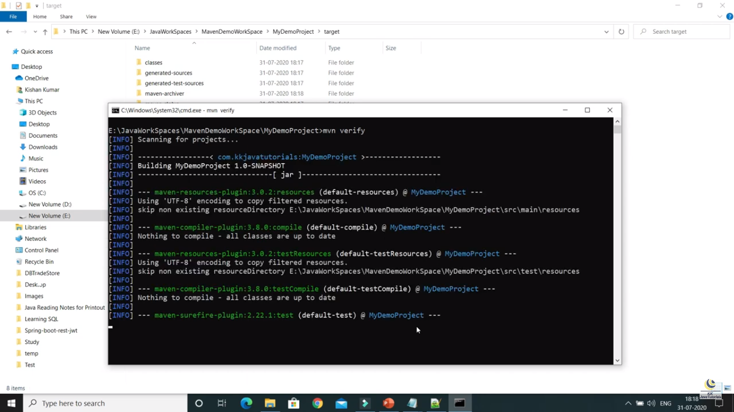

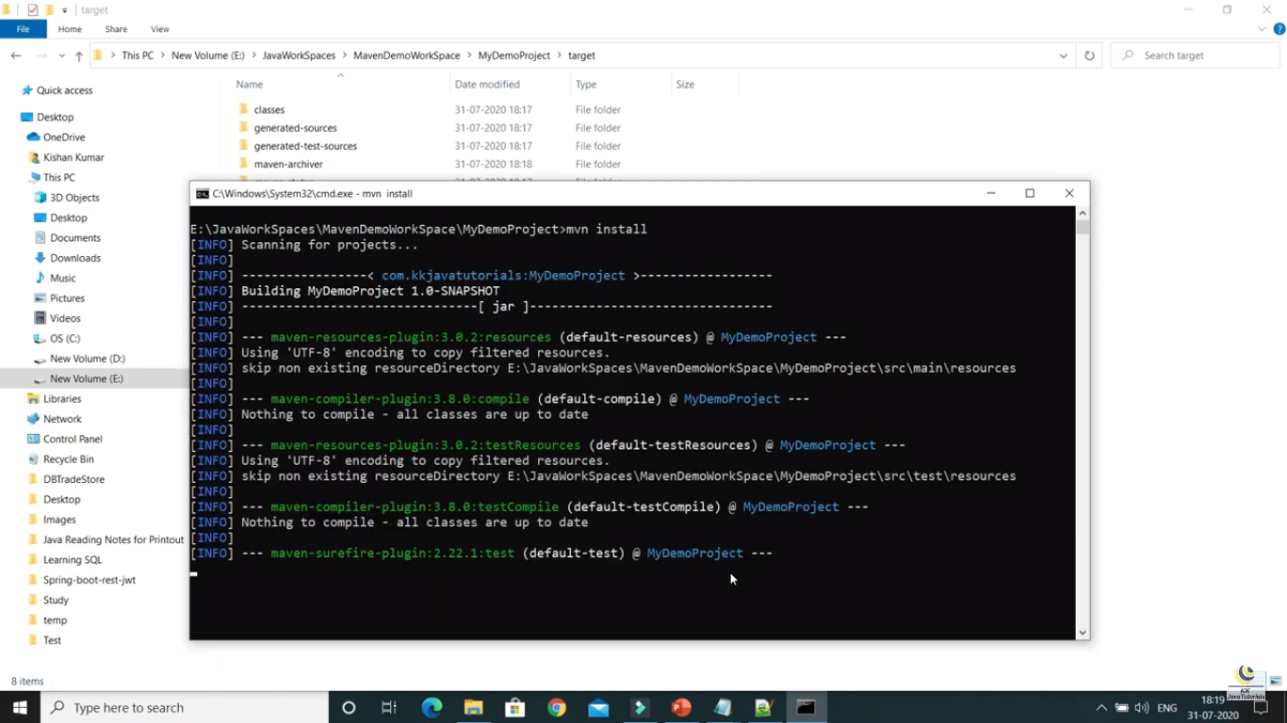

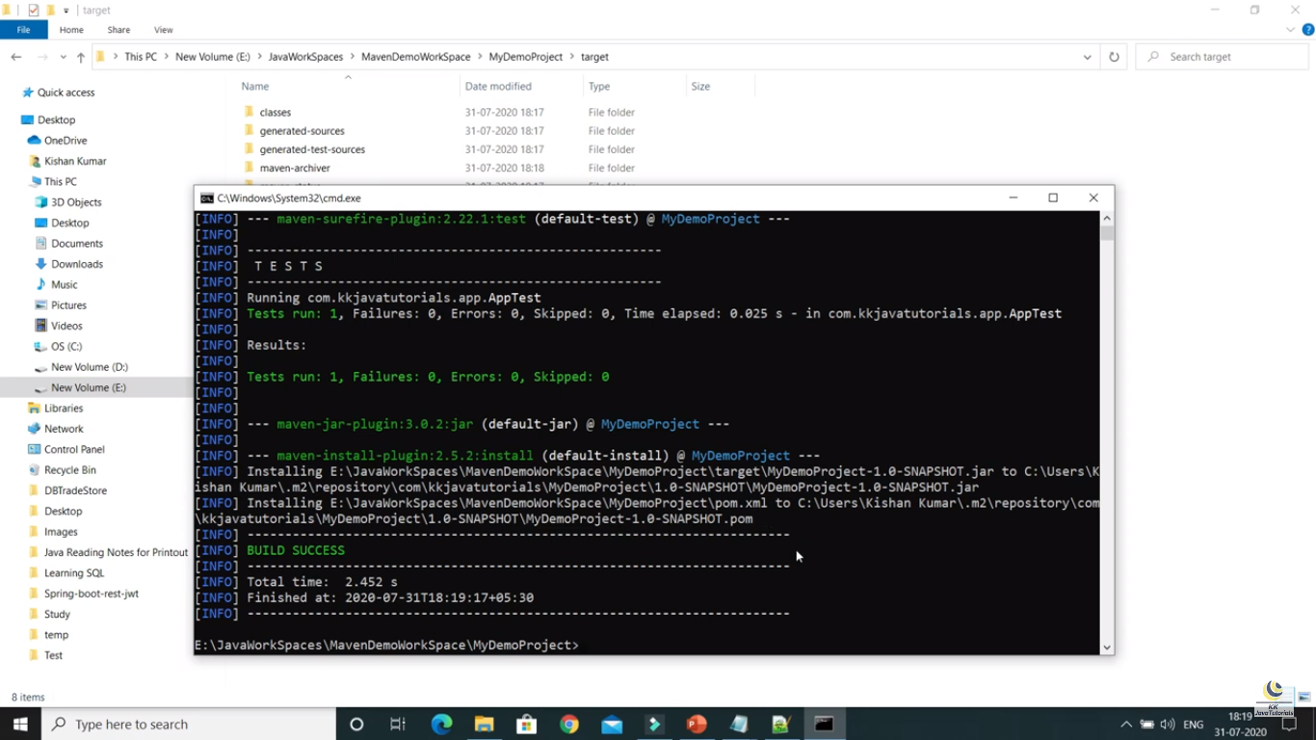

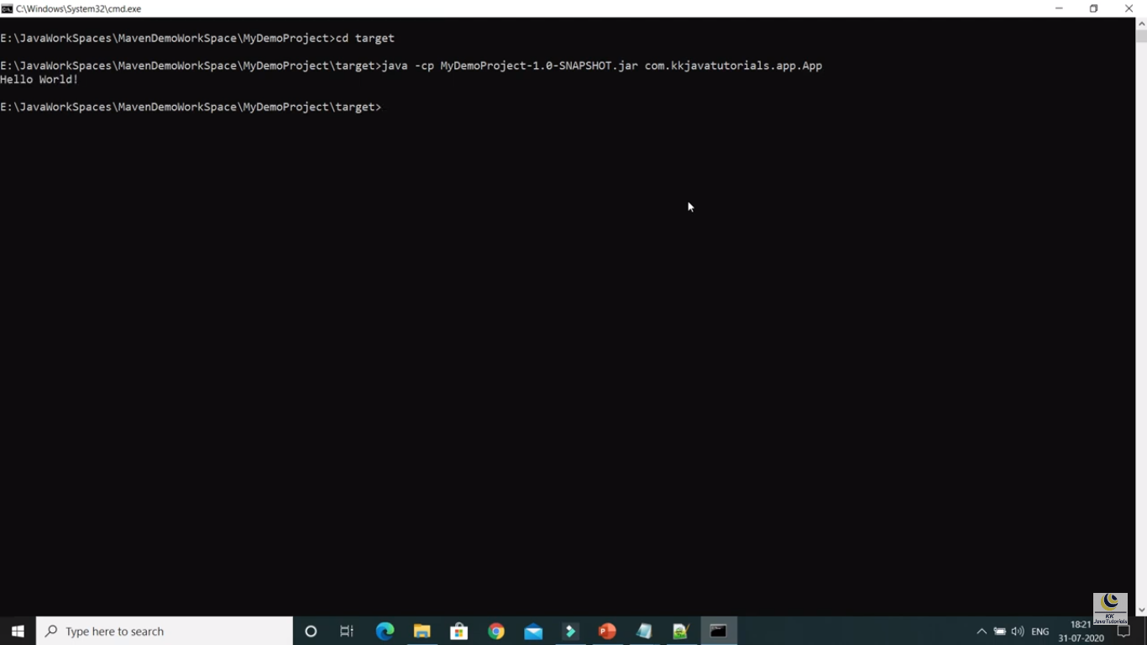

Part – 4 :

**Creating Maven Project using eclipse:**

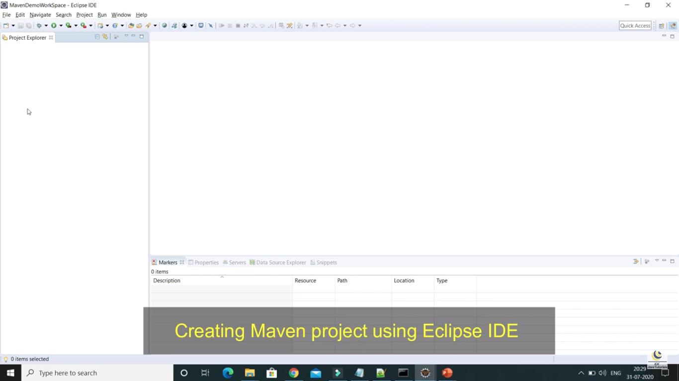

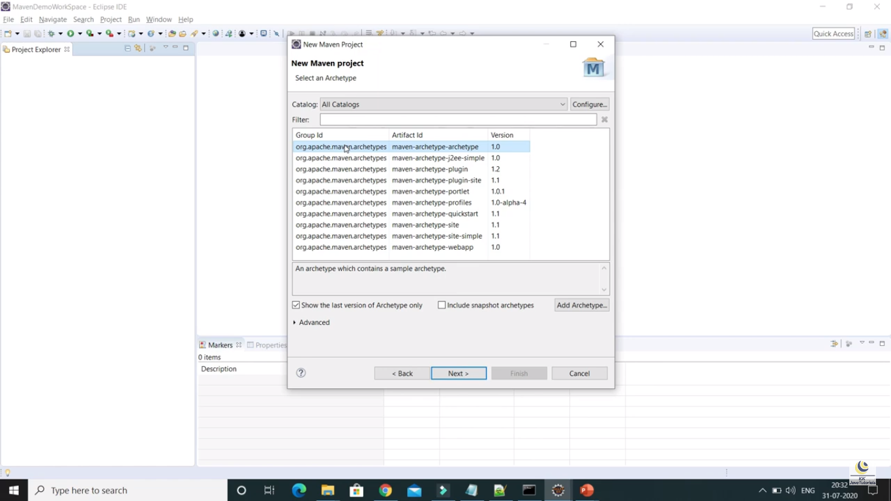

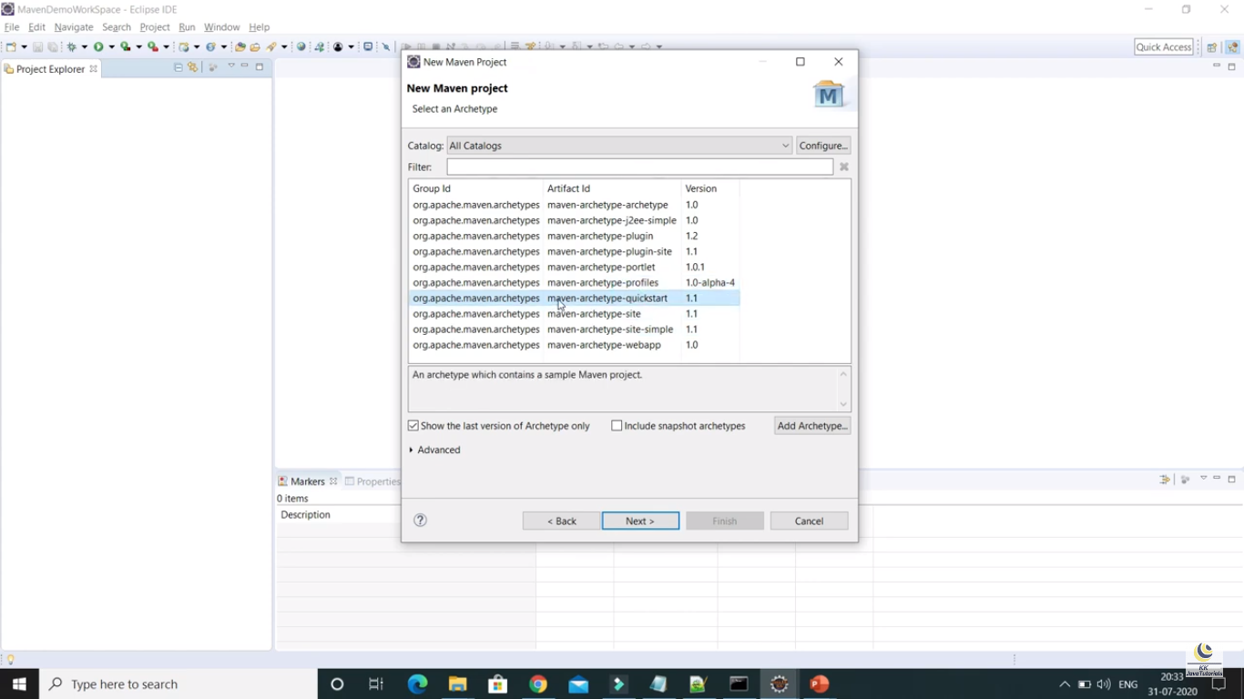

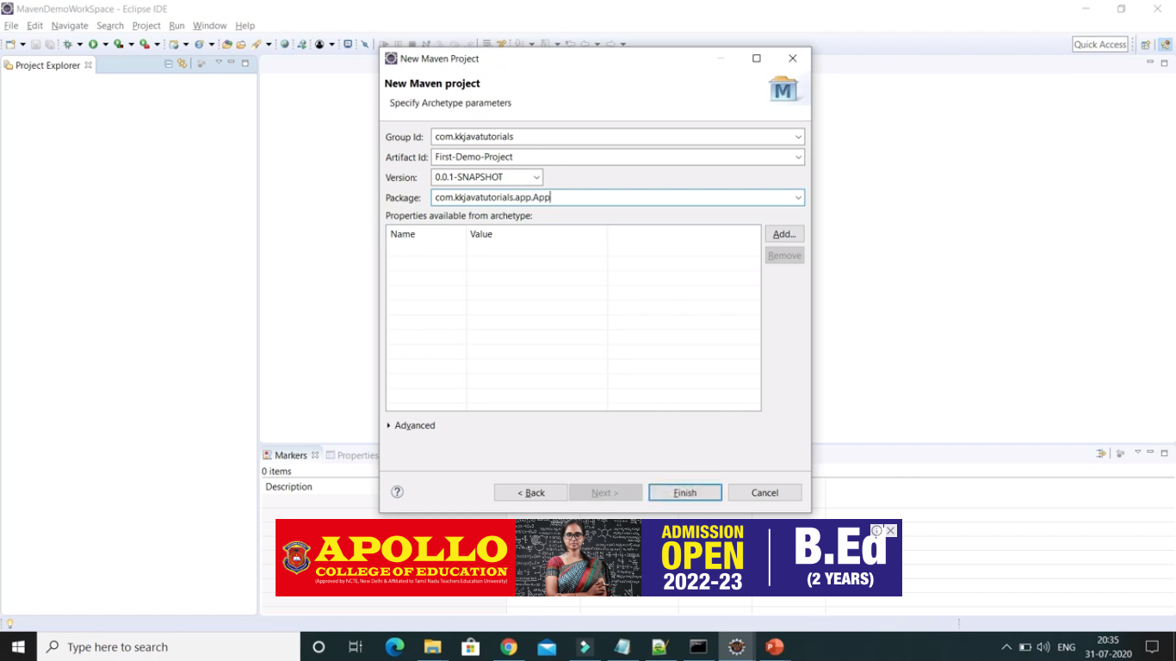

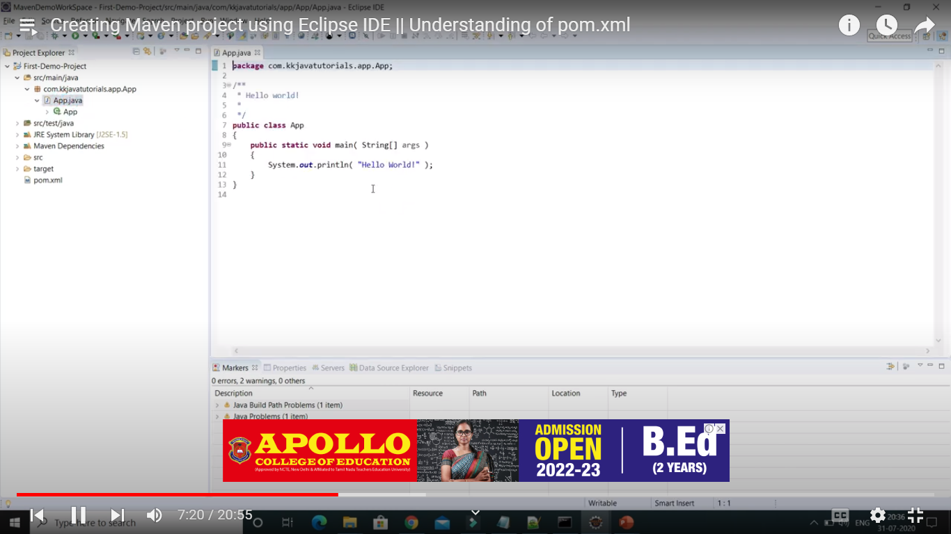

mvn clean – This command is used to delete the target directory from the application

mvn compile – This command is used to generate .class files for all the java classes

To check whether maven plugin is already installed in eclipse or not, we need to follow the below steps

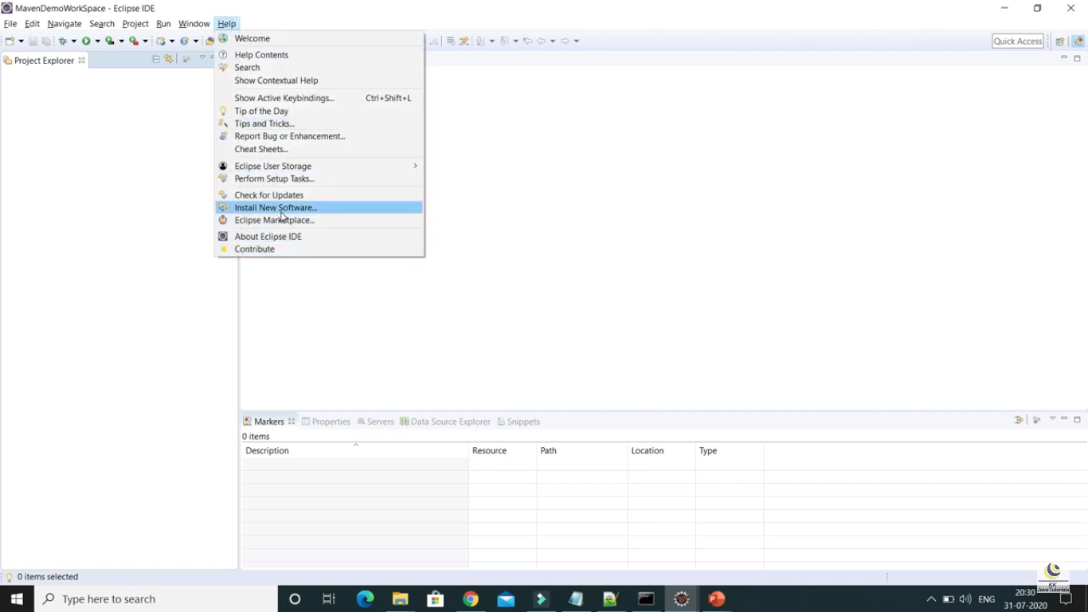

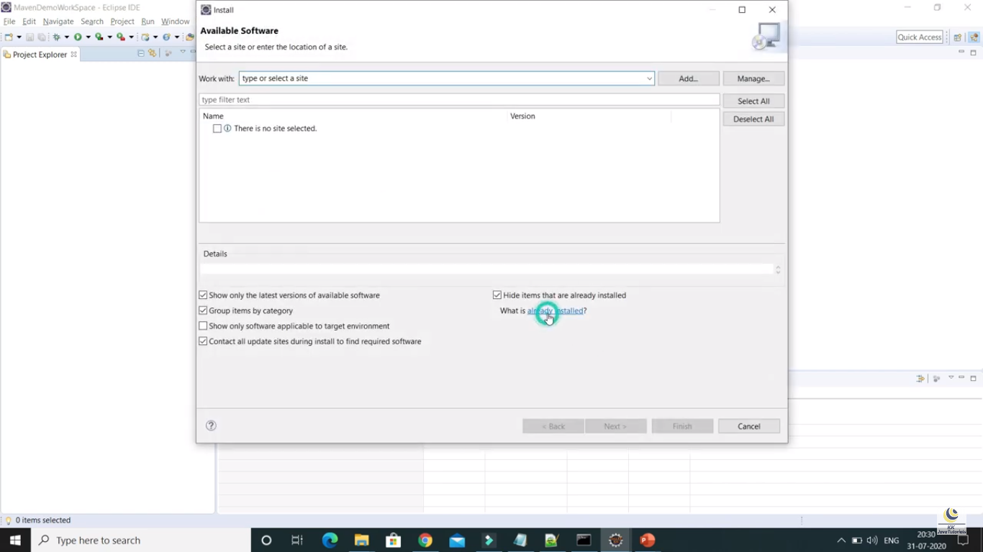

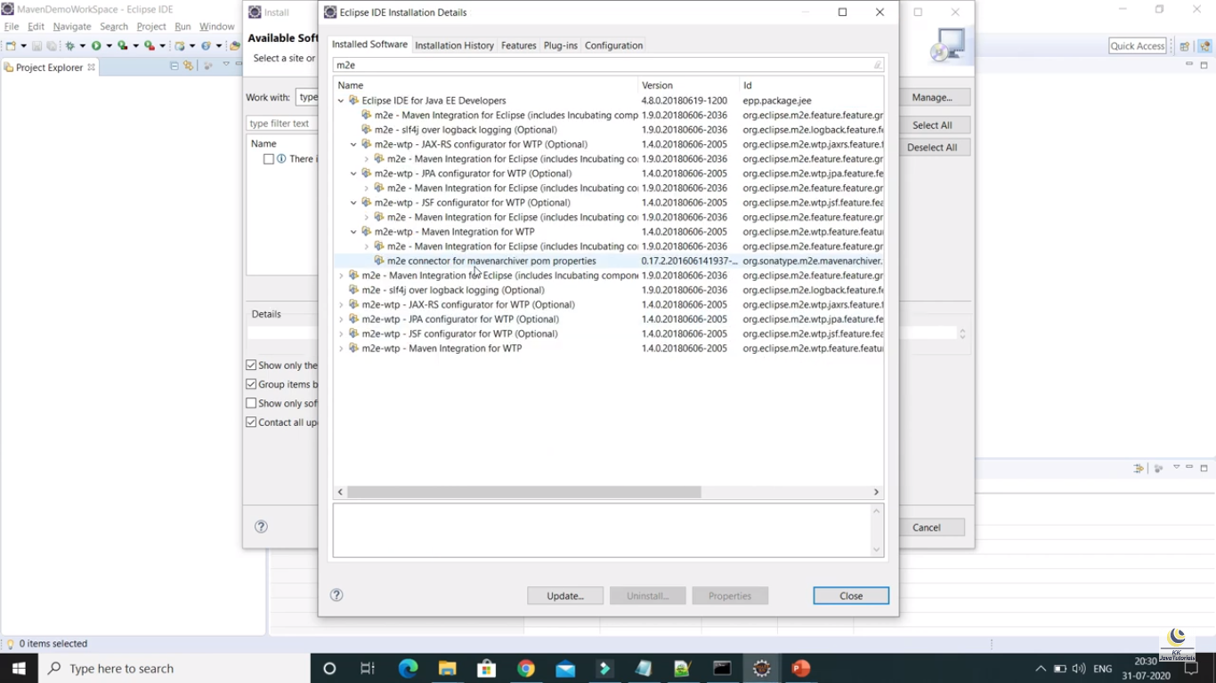

Part – 6 : Create Maven web application in eclipse

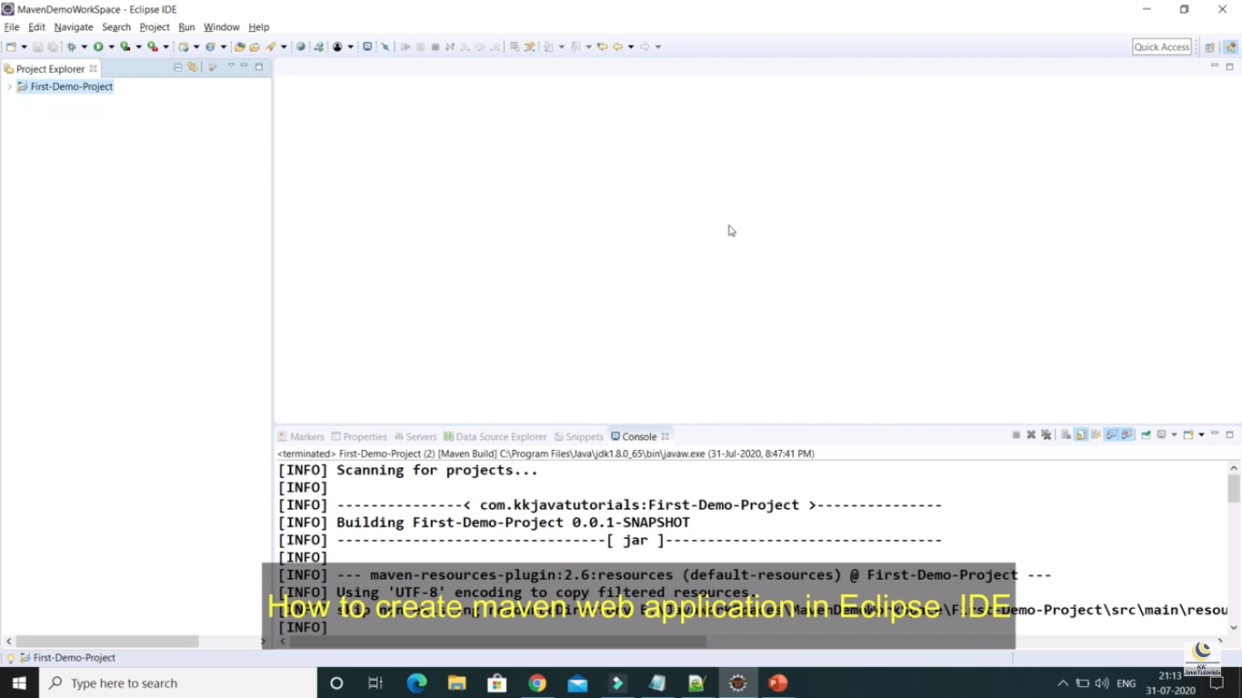

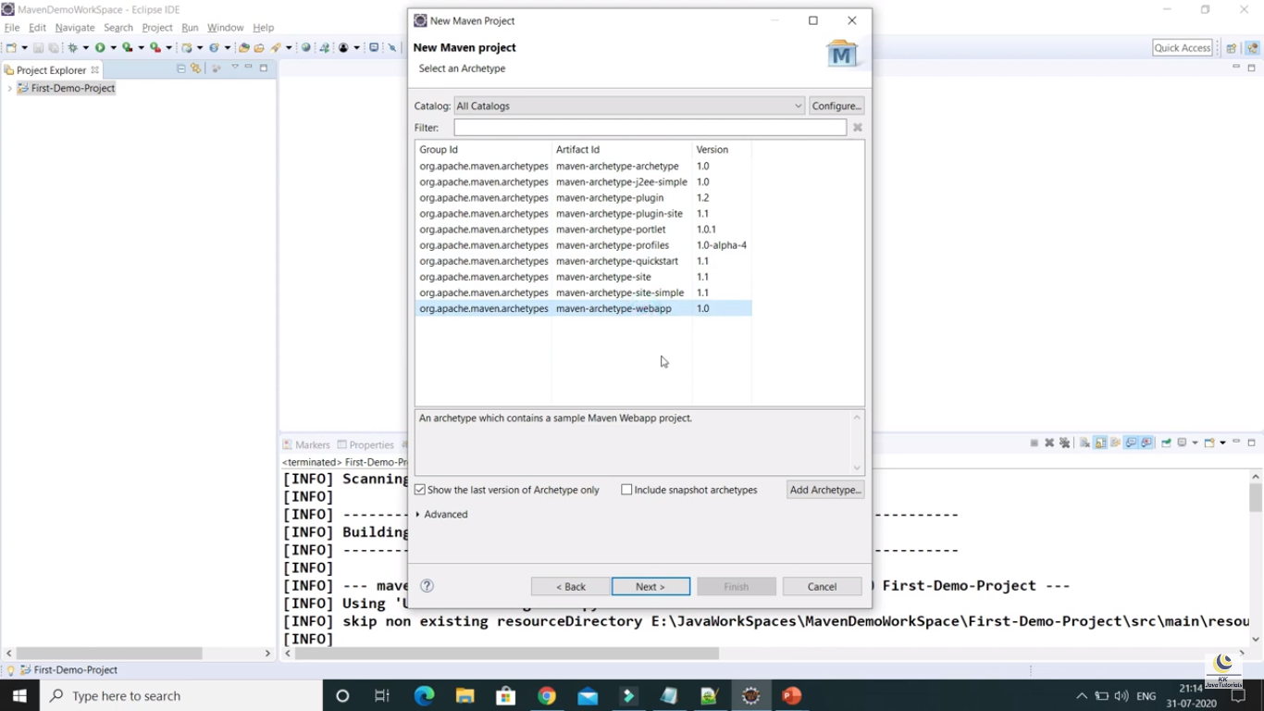

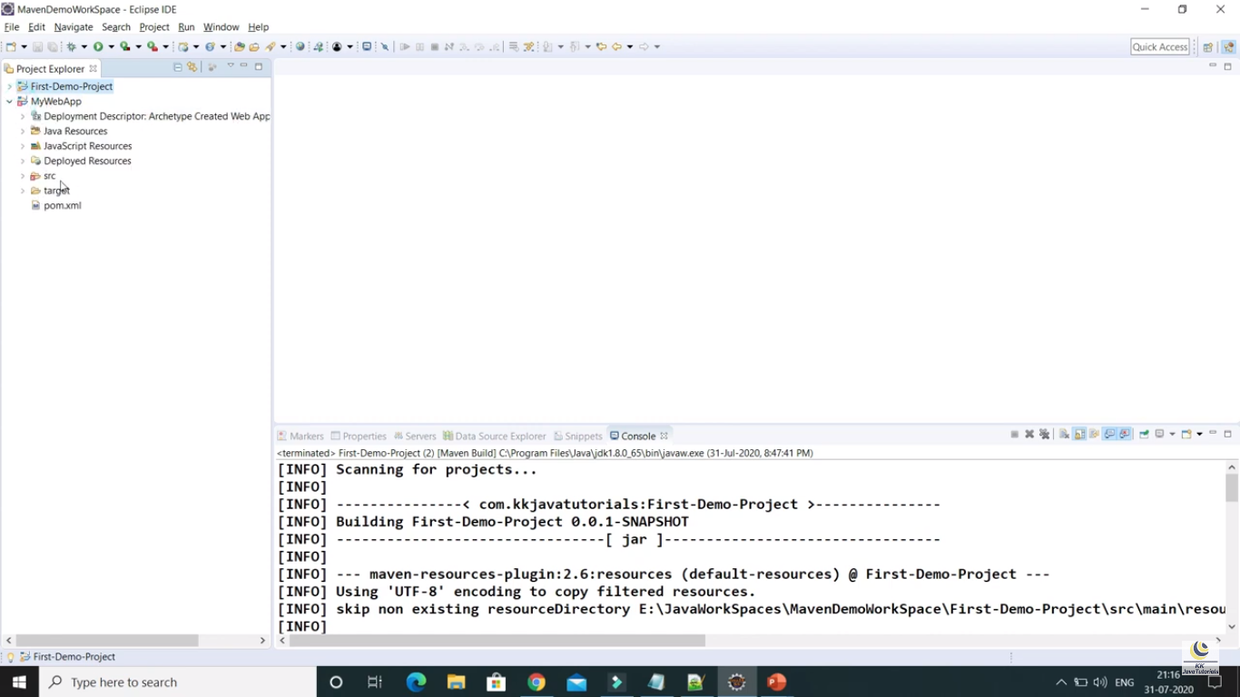

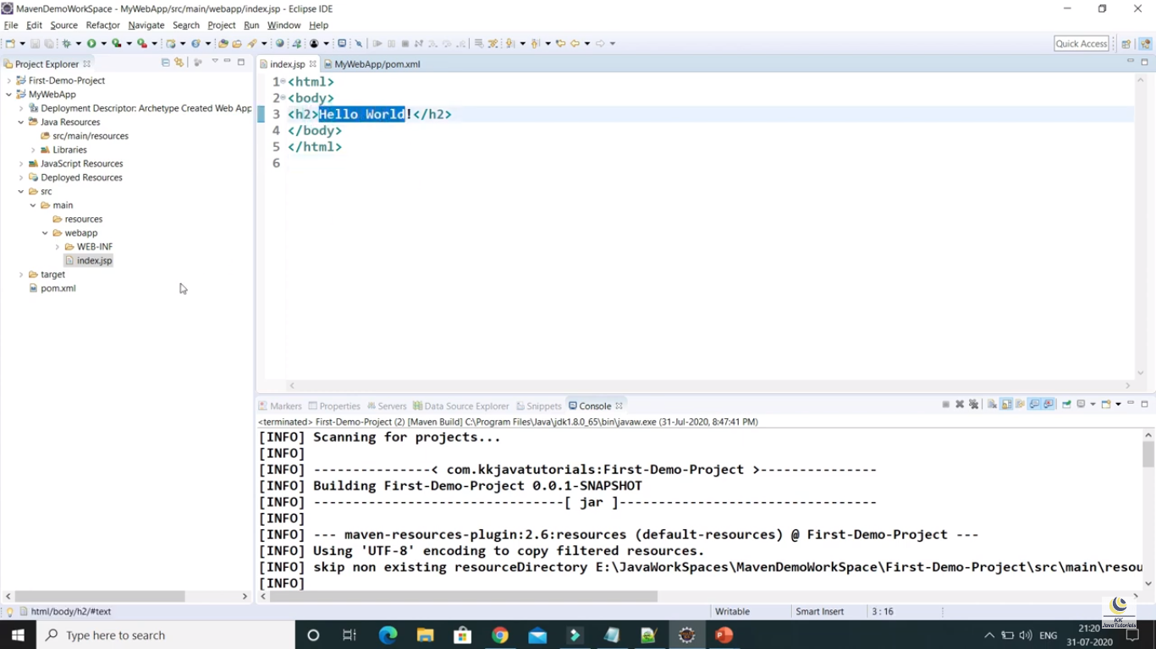

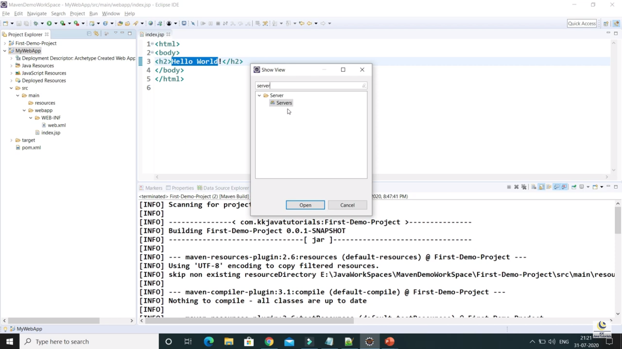

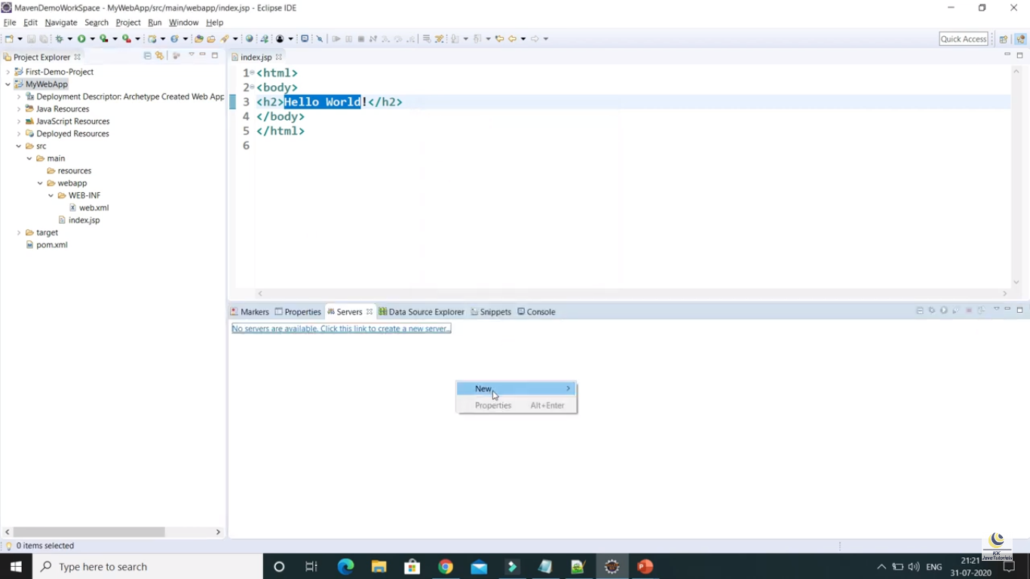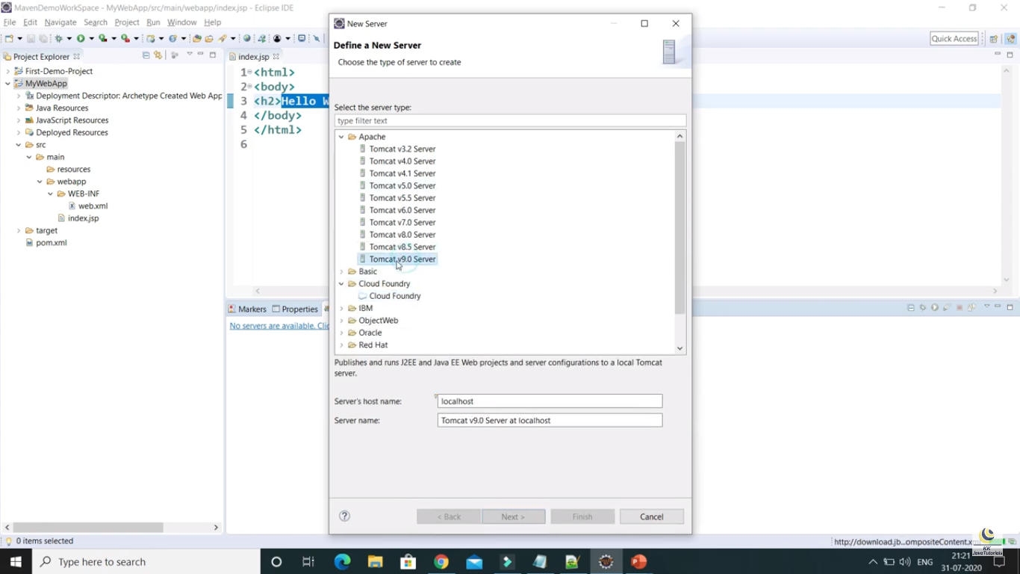

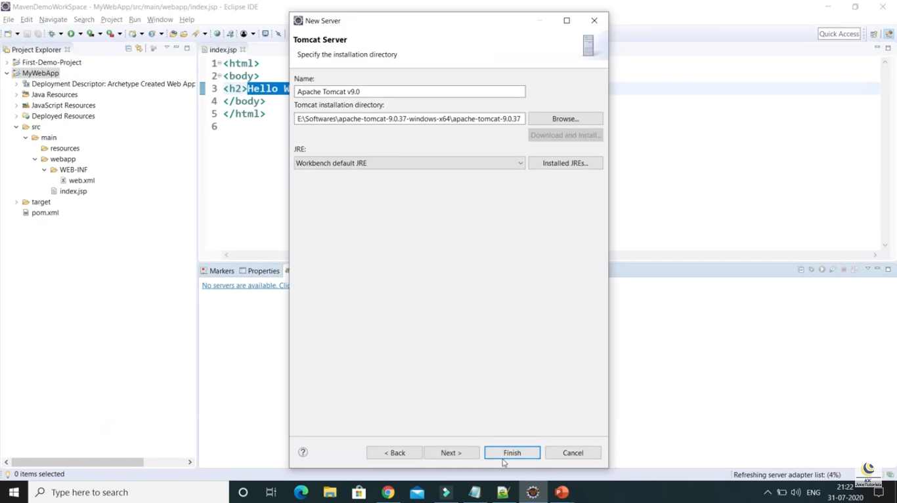

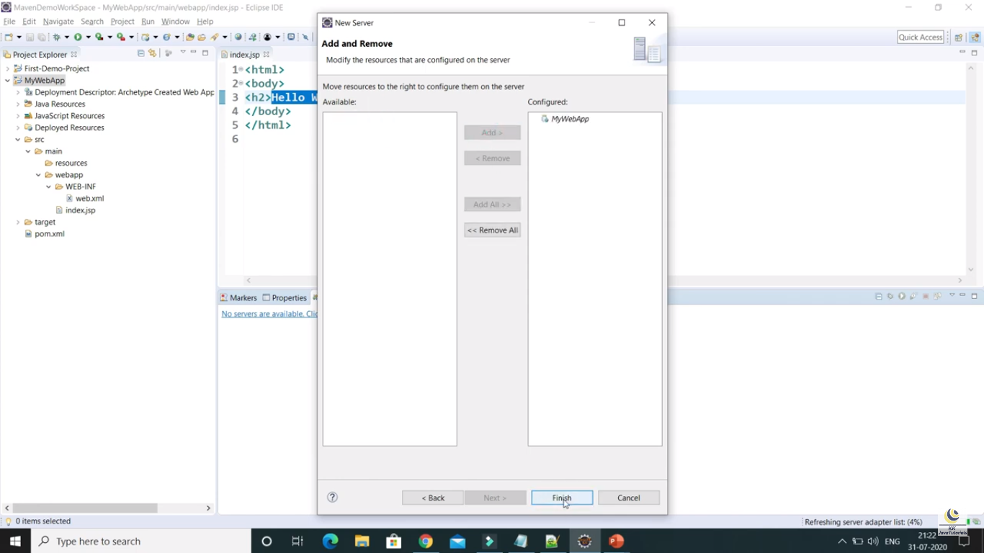

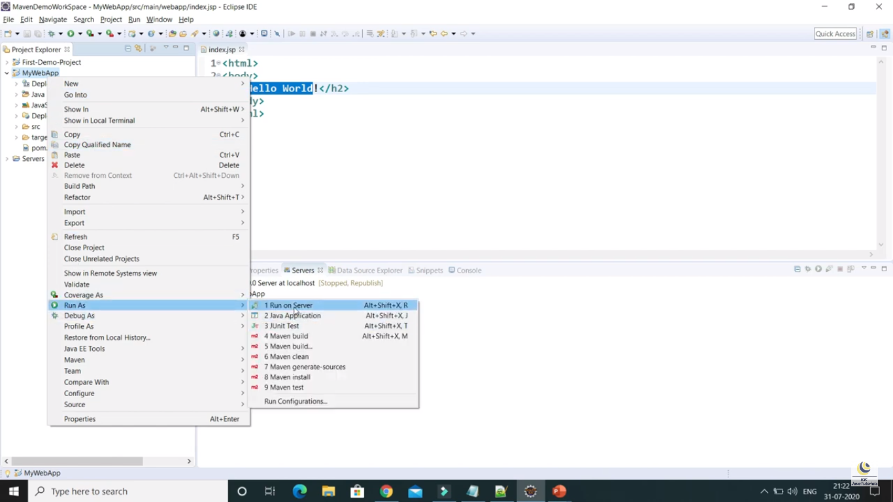

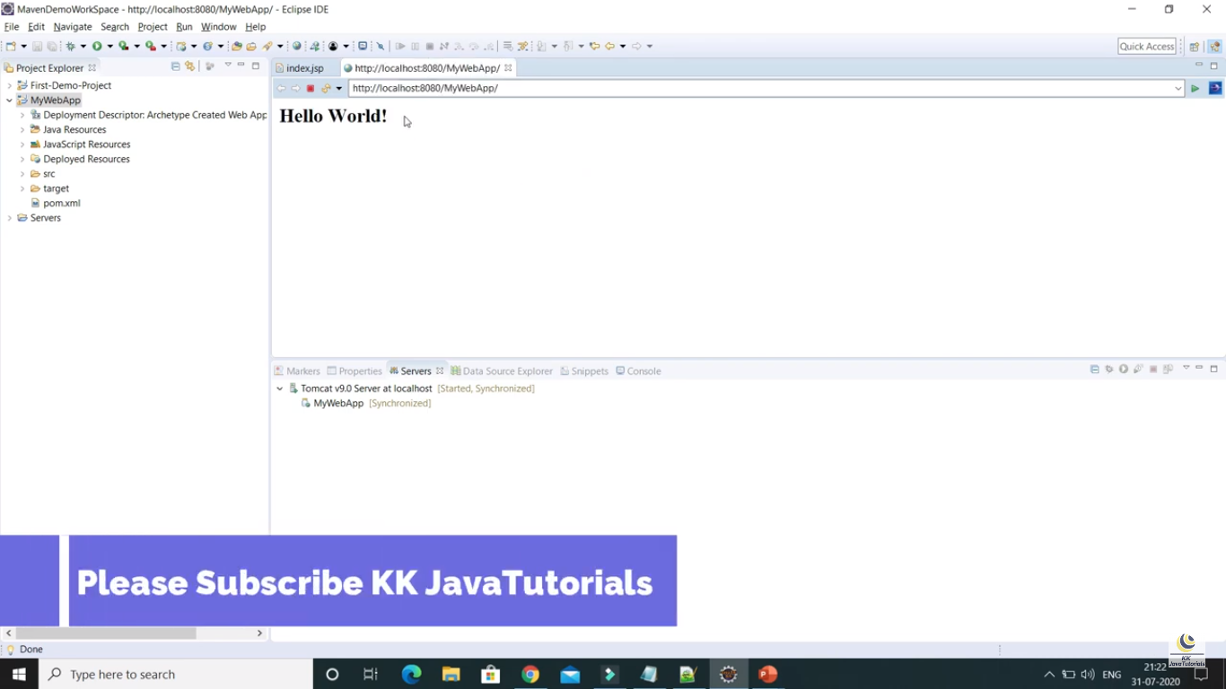

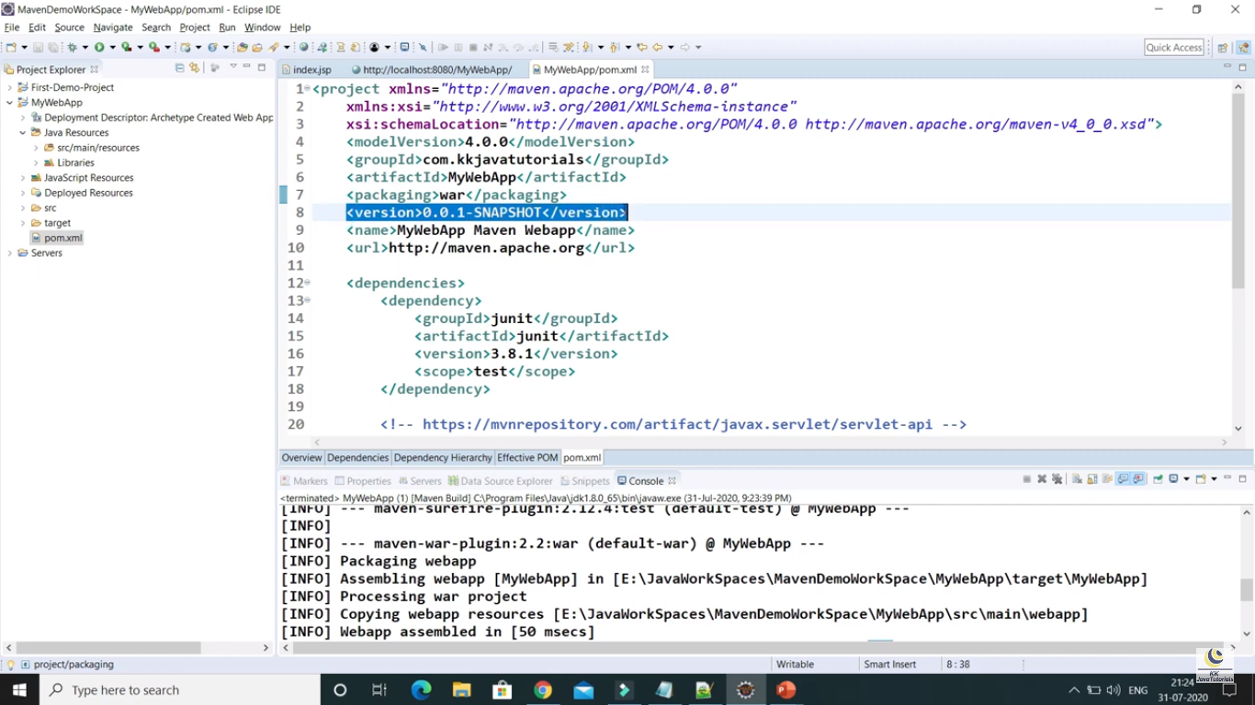

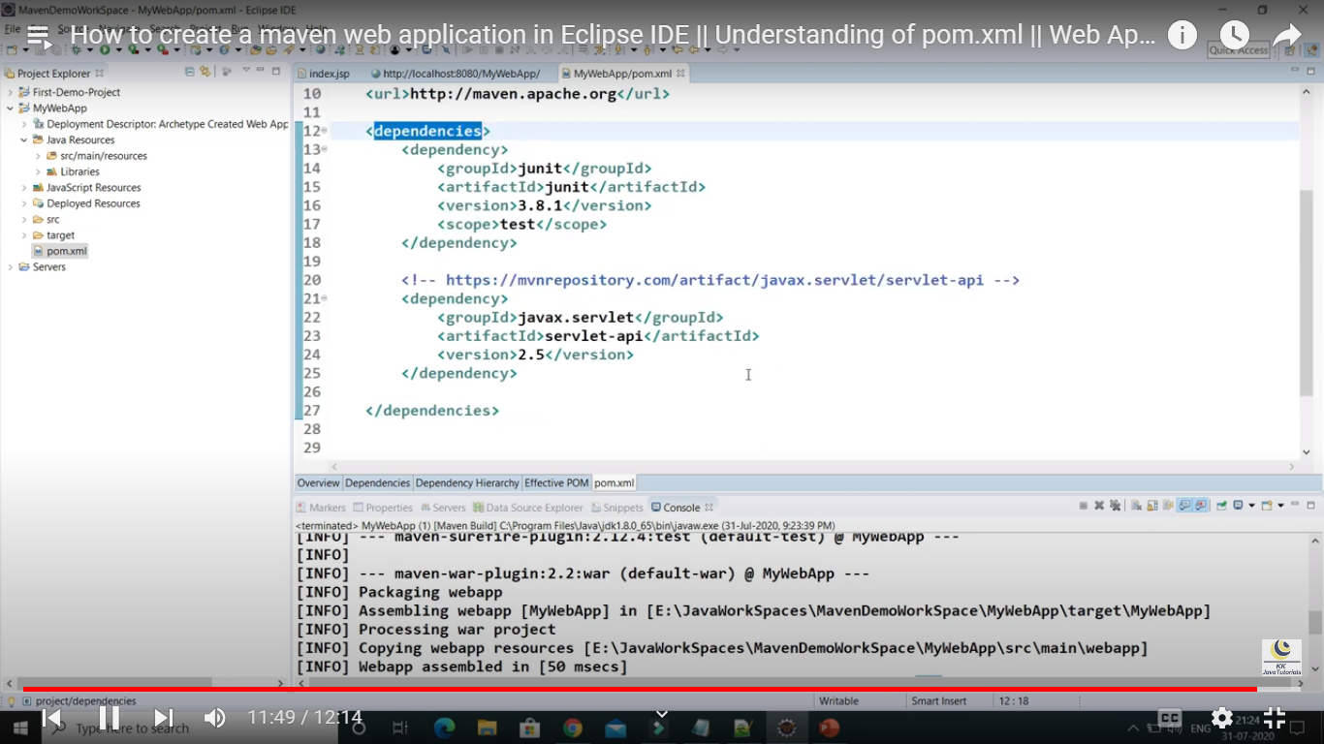

Part – 7

How to import the project from GitHub in eclipse workspace

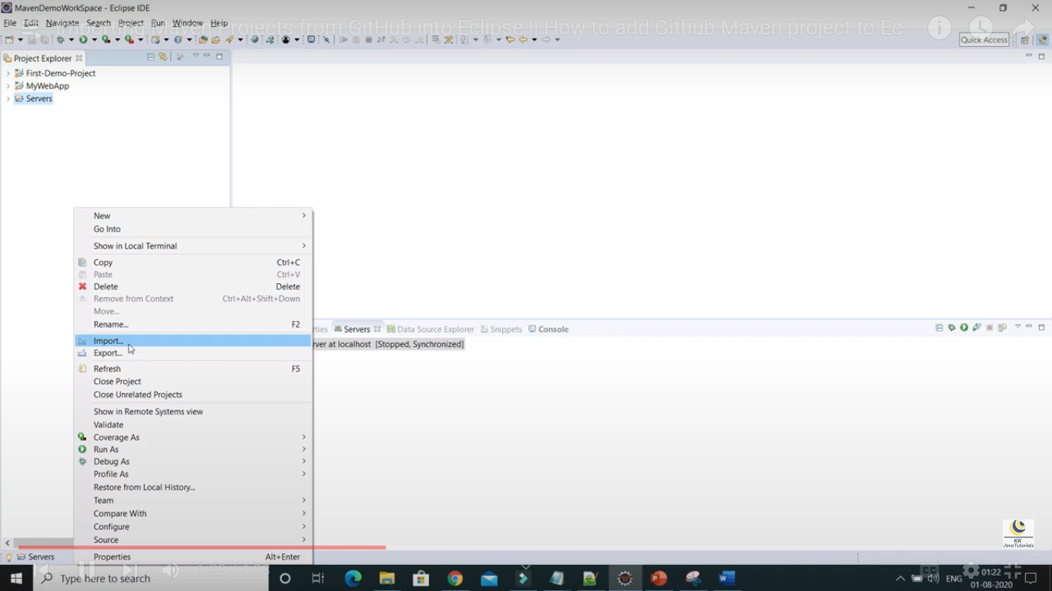

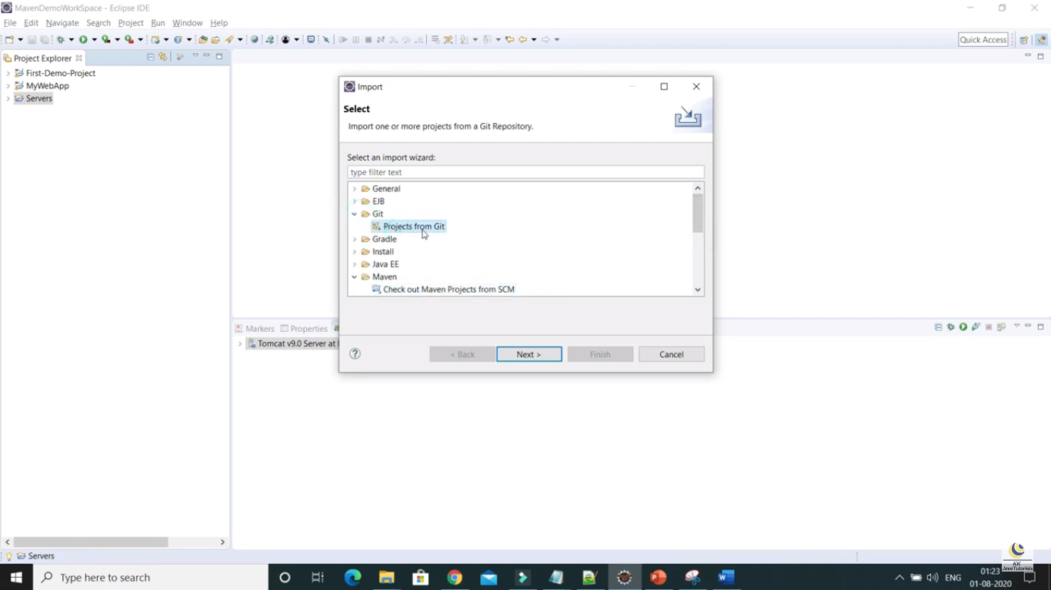

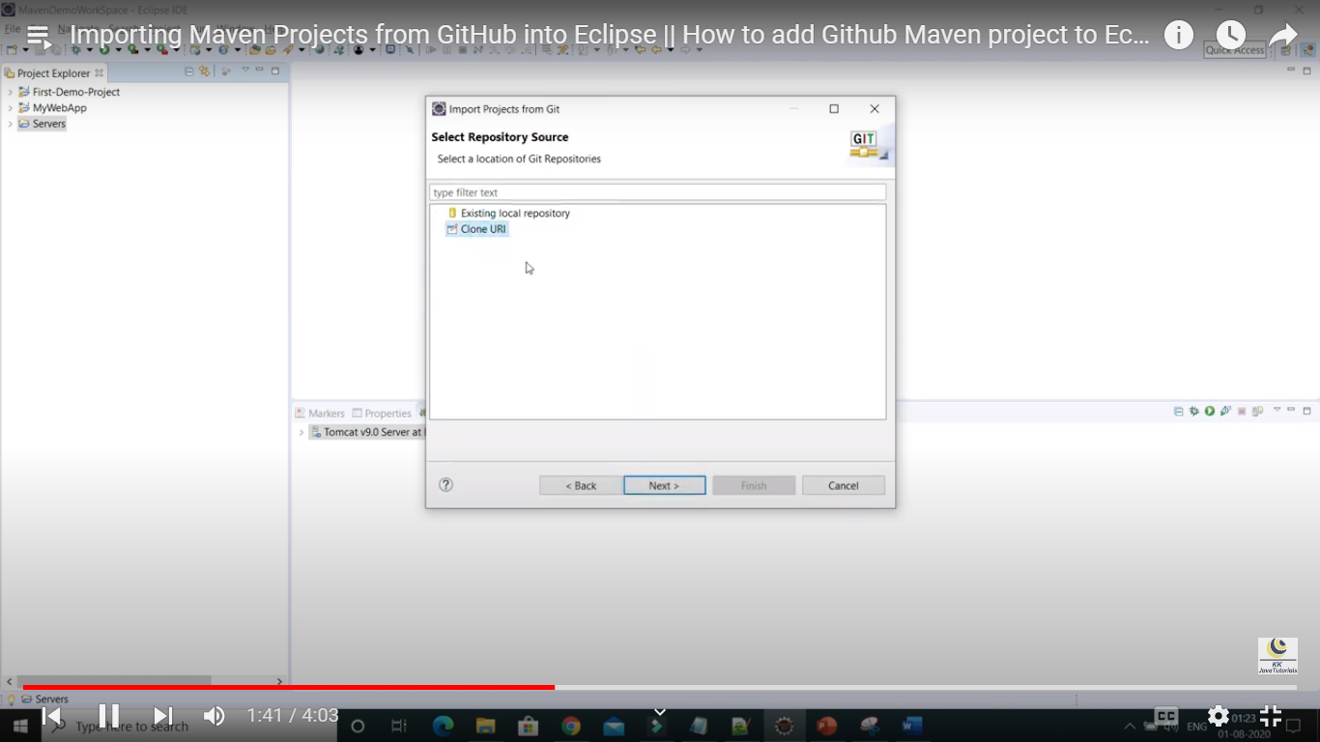

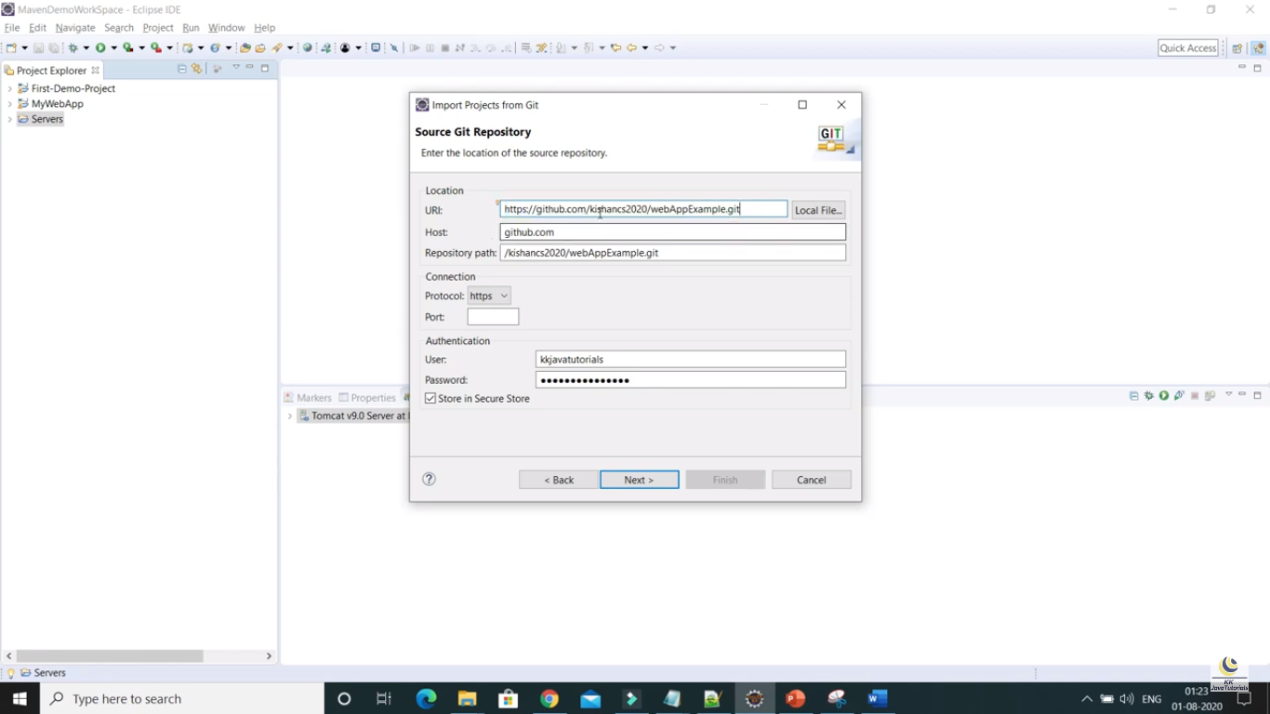

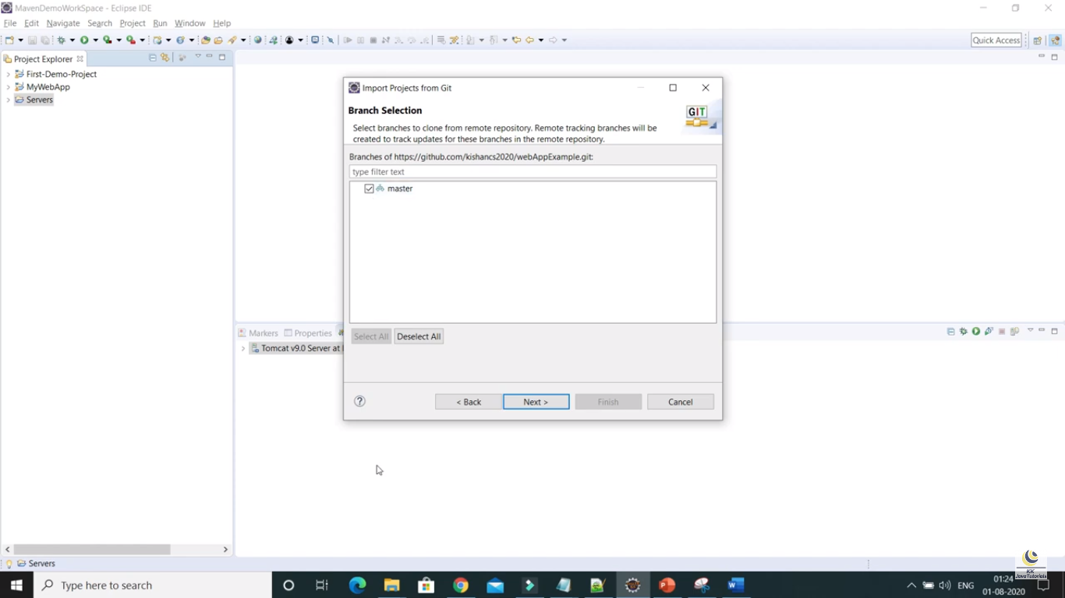

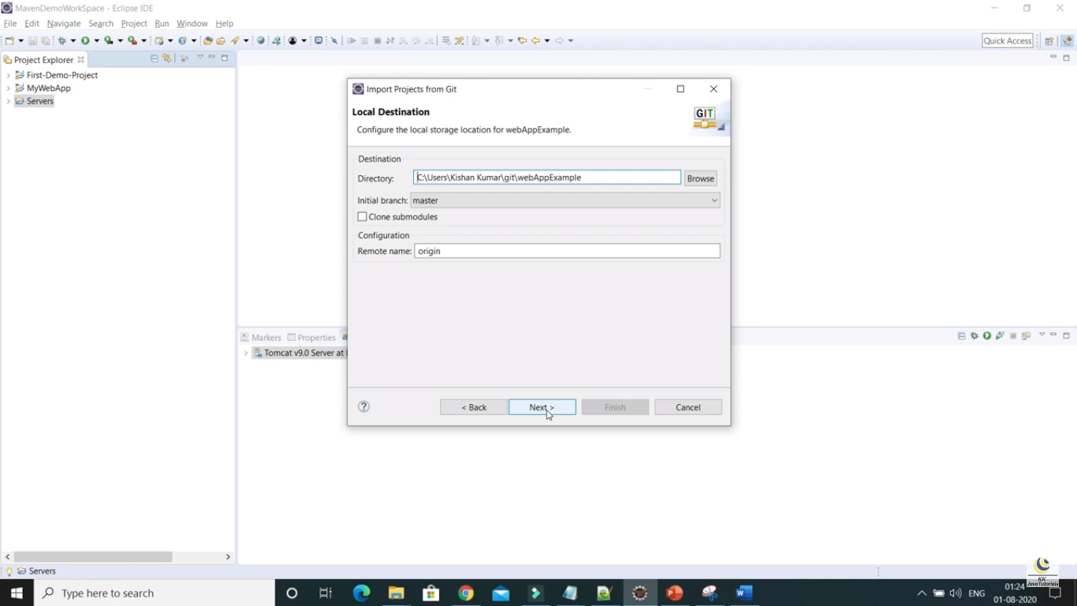

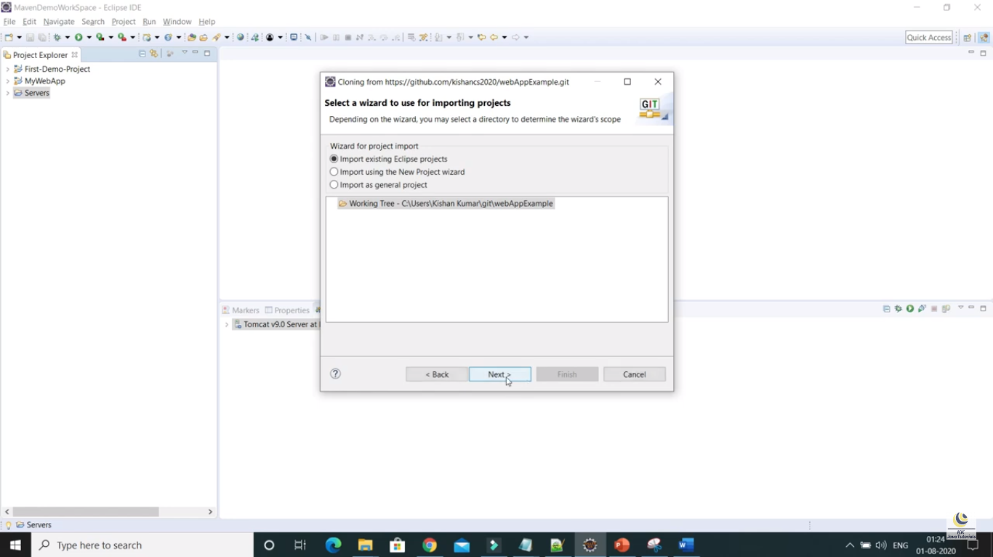

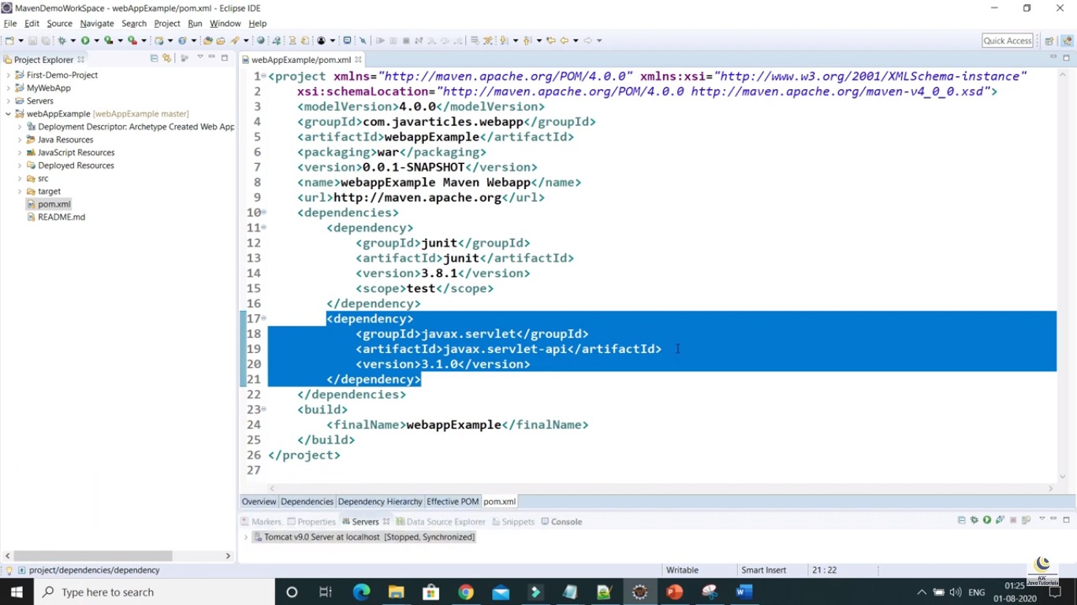

# Part – 8 : Java Maven Web Application Project Deploy|| How to run the maven web app in an embedded jetty server

Adding jetty plugin in pom file as below

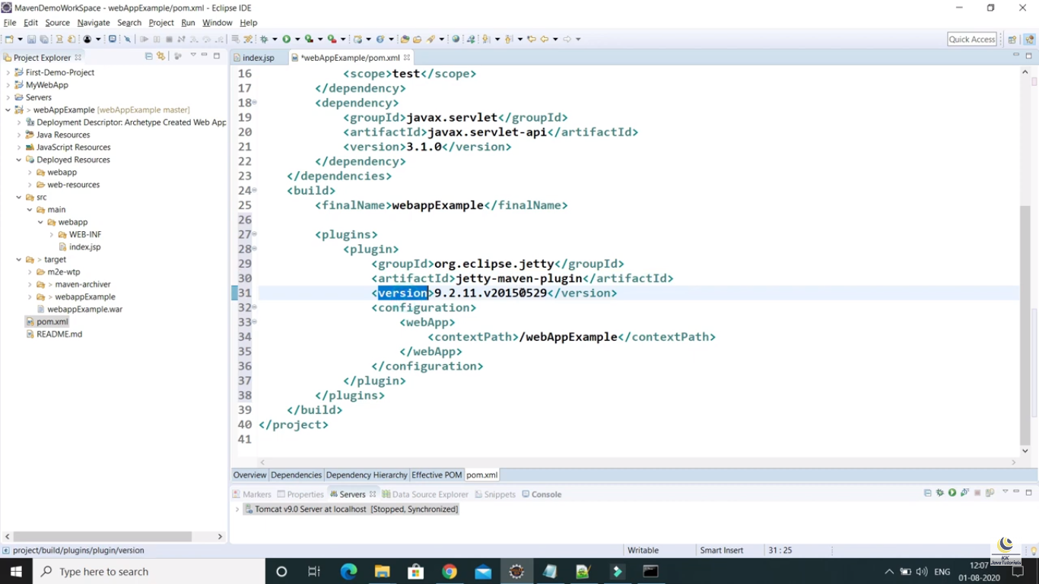

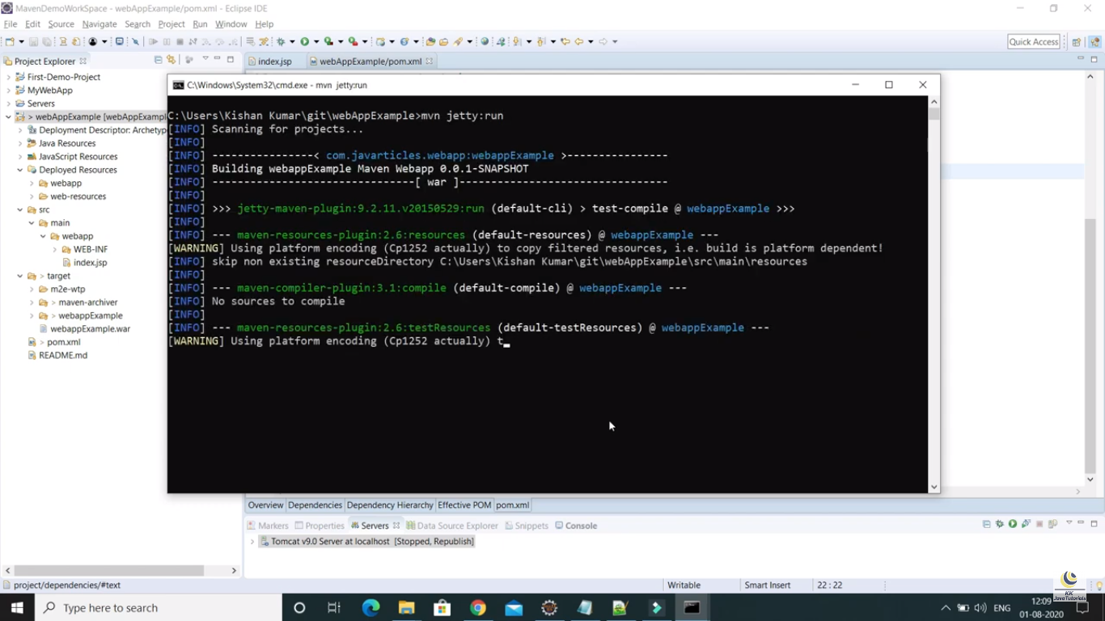

Navigate to the source code path and then open command prompt and run the above command to run the application in jetty server.



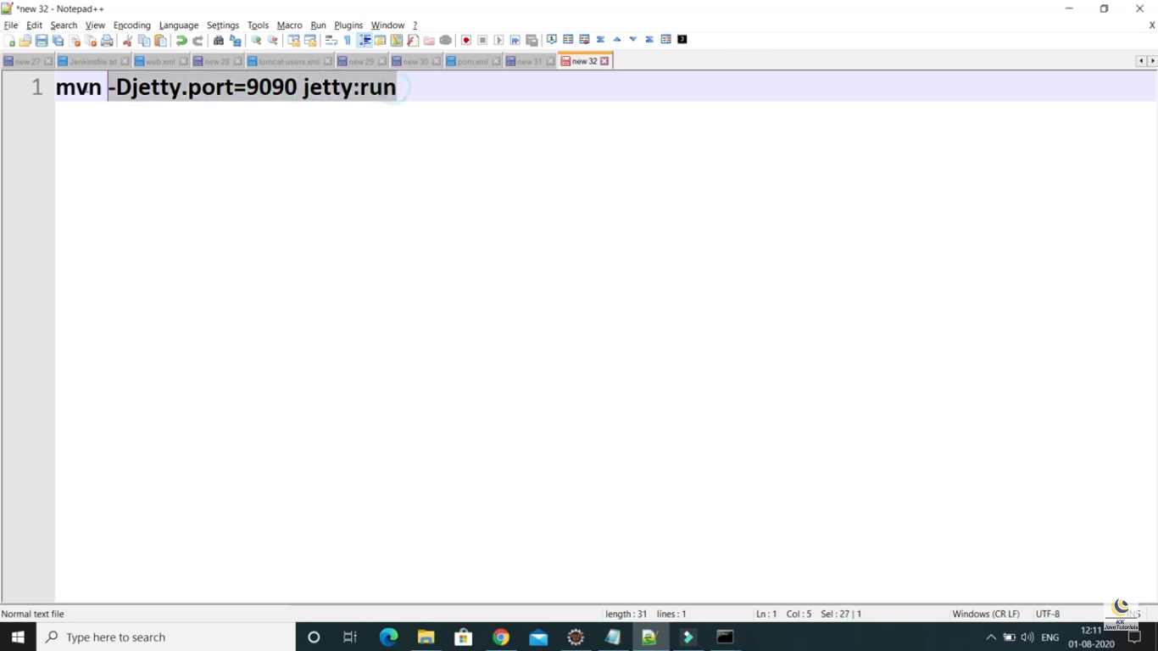

To run the application on another port then we have to follow the above command

# Part – 19: What is POM in Maven

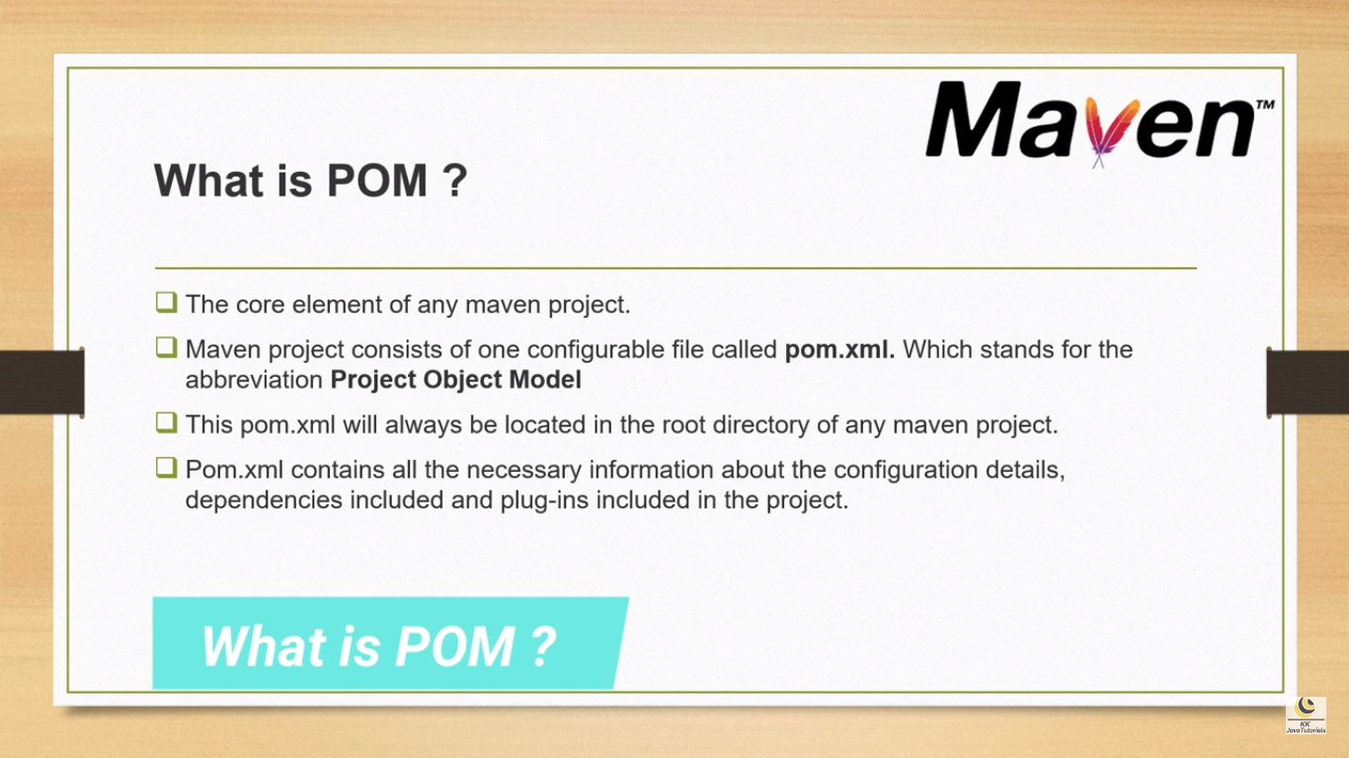

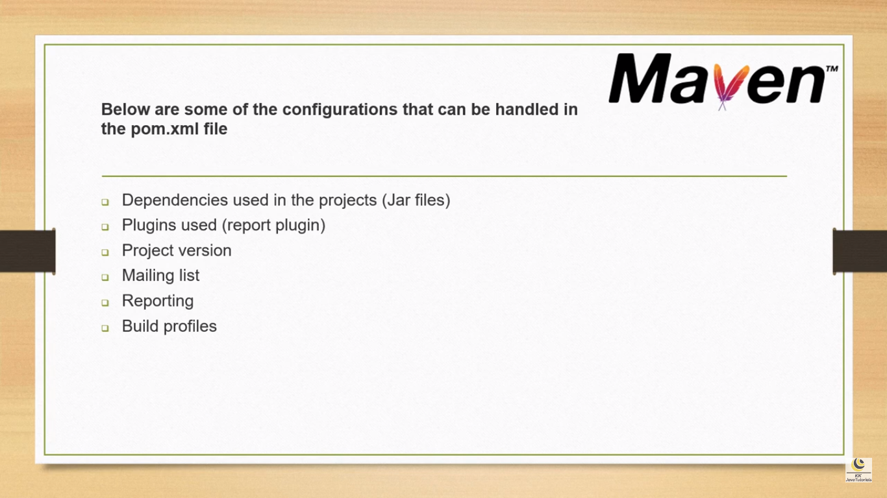

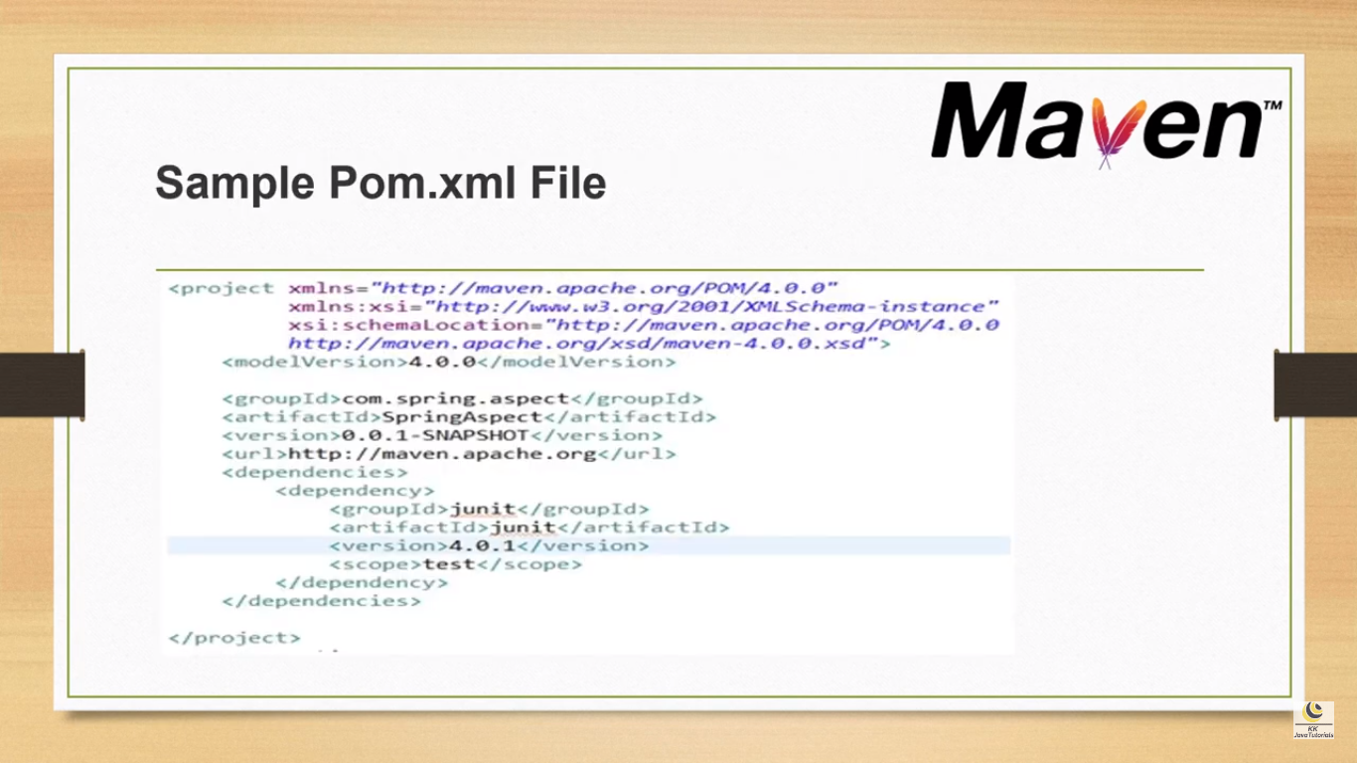

# Part – 20 What is Super POM in Maven?

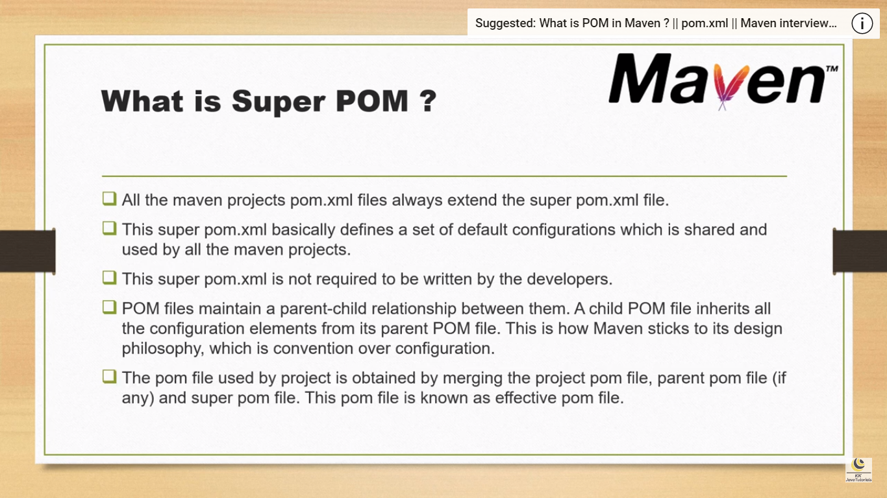

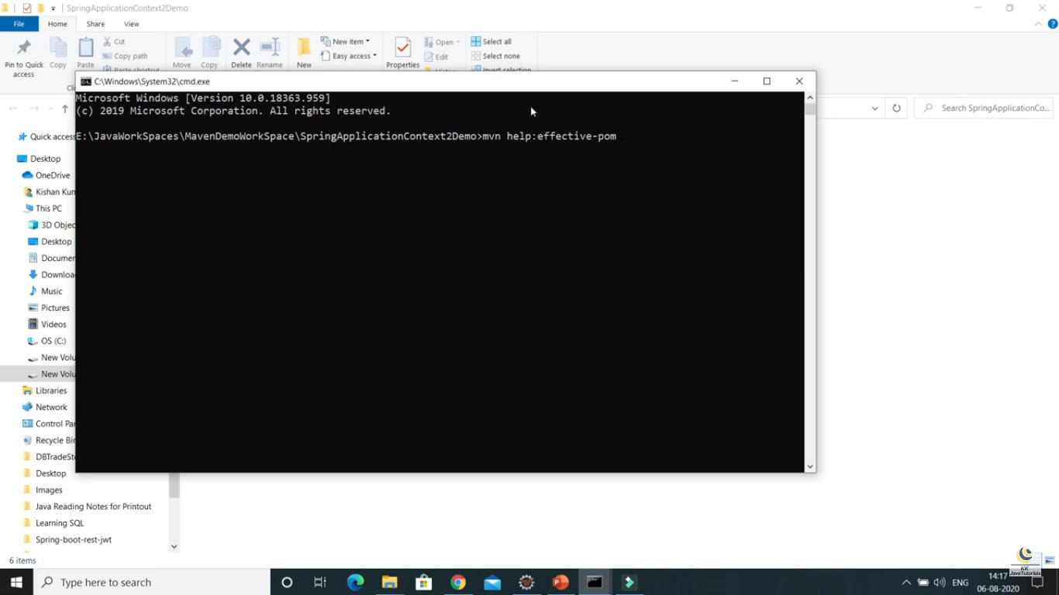

When we run the above command in the project then the super pom file will display.

# Part – 21 : Snapshot Vs Version in Maven

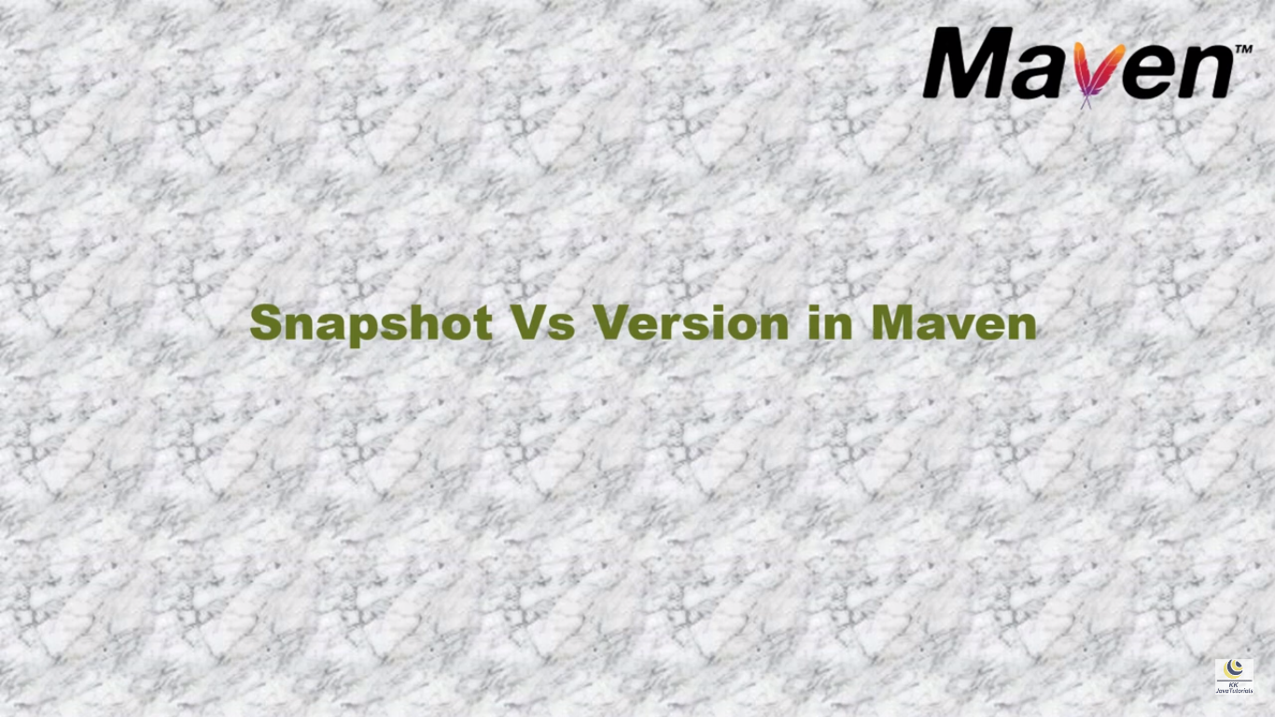

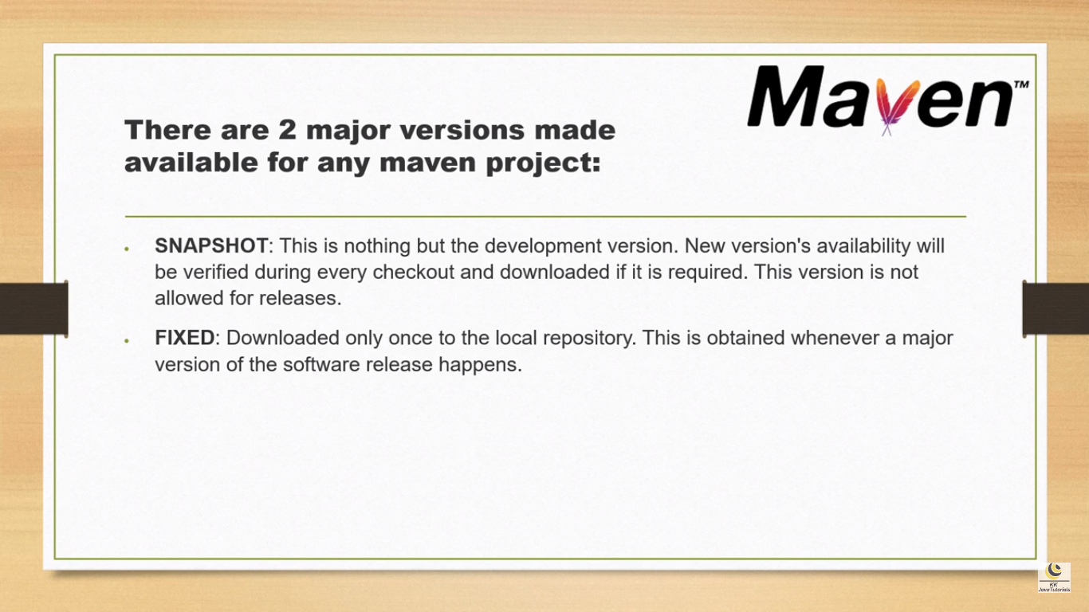

# Part – 29 : The trick to add maven dependency||Enable index downloads in Eclipse for Maven dependency search?

# Part – 24: Understanding of Maven Repositories



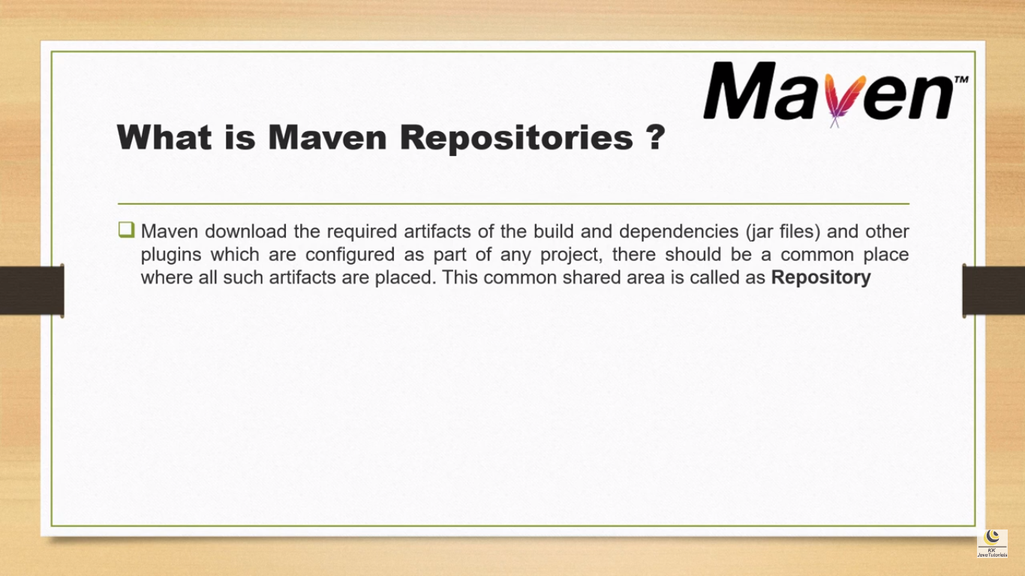

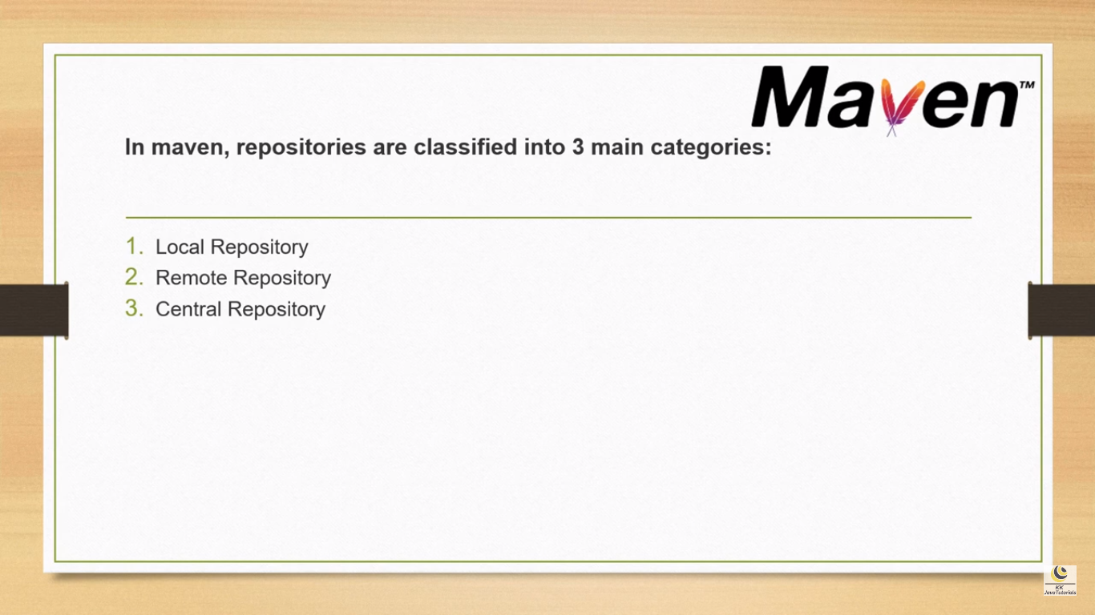

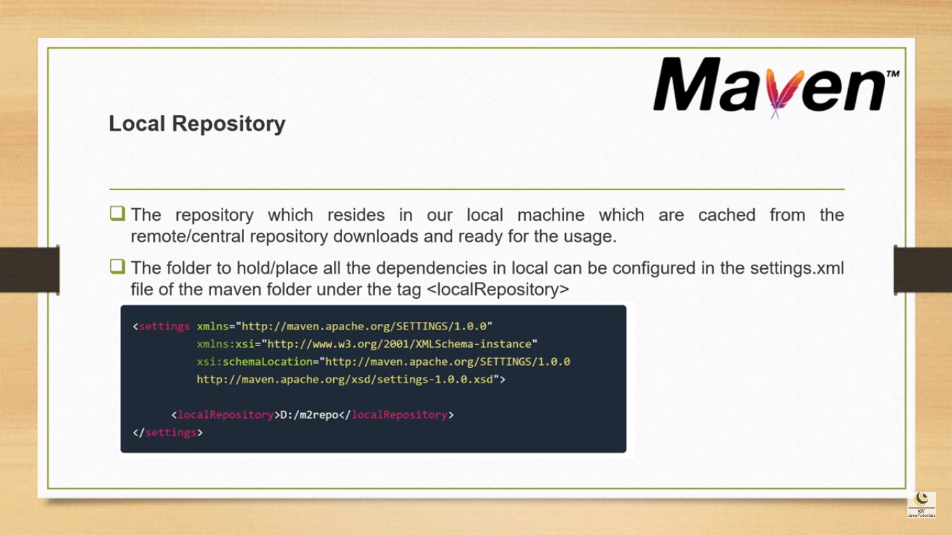

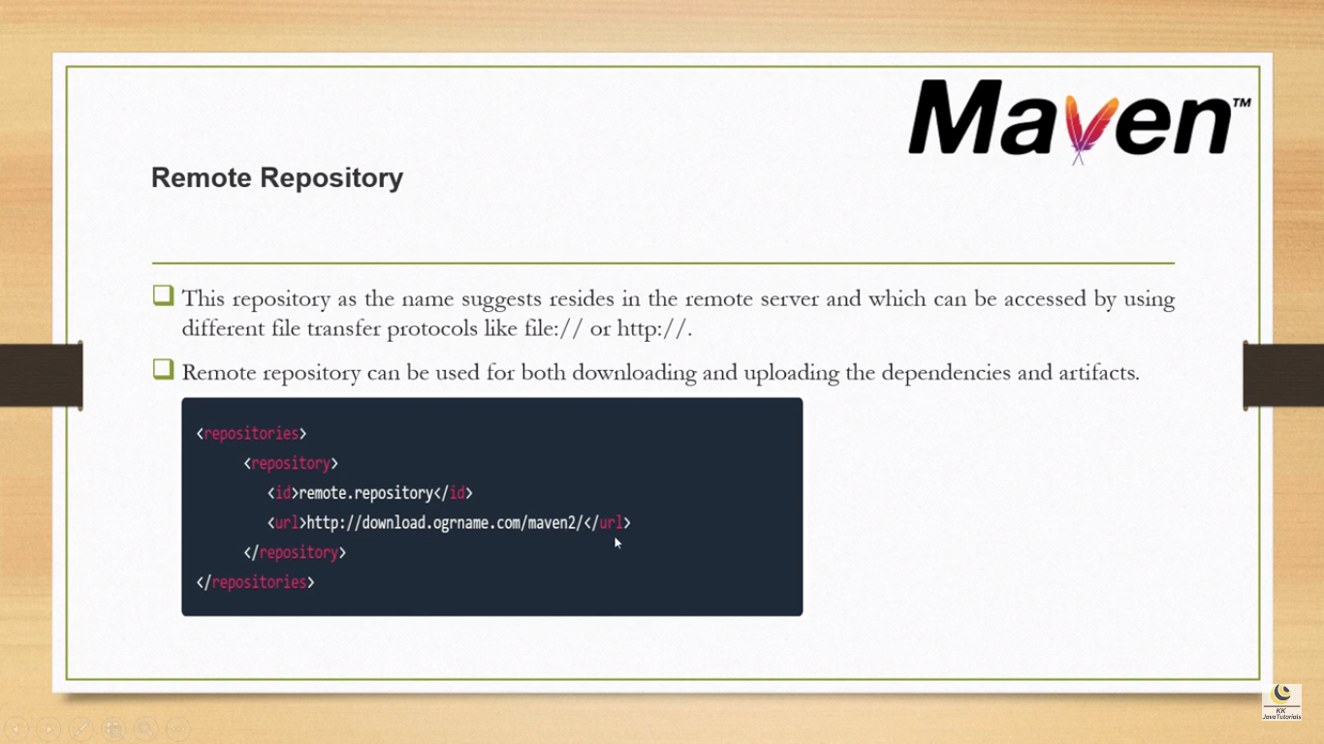

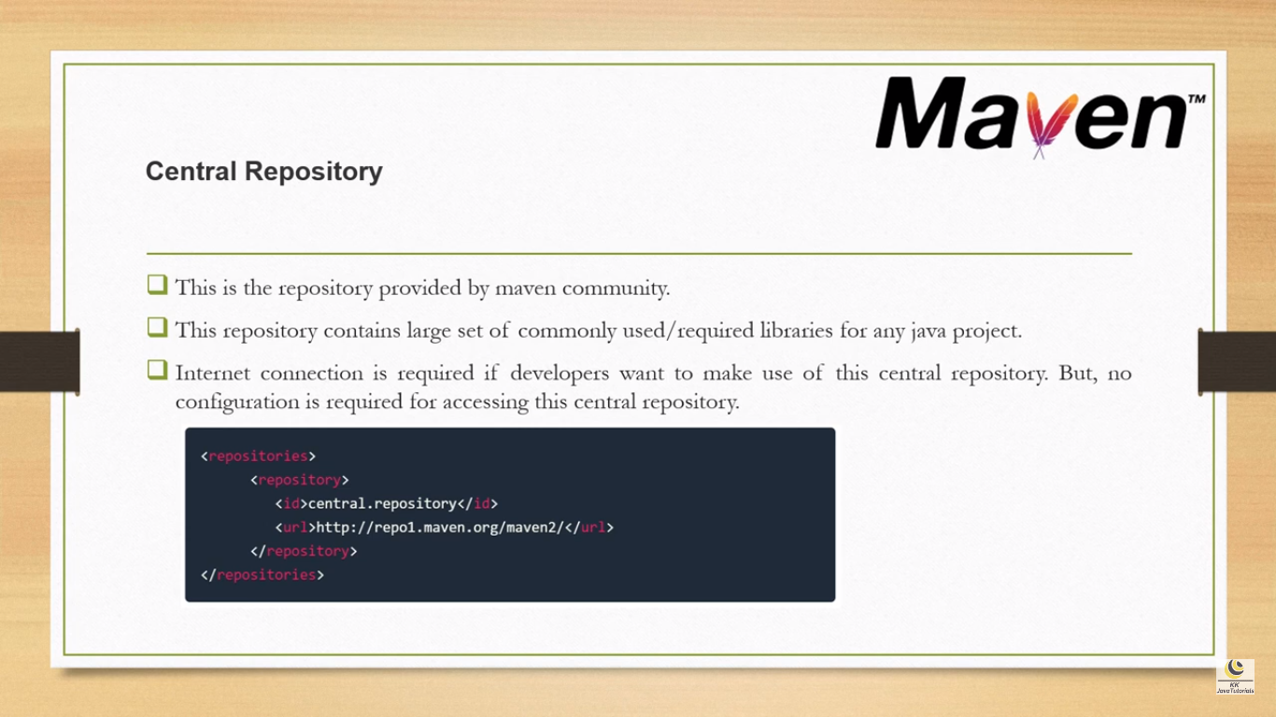

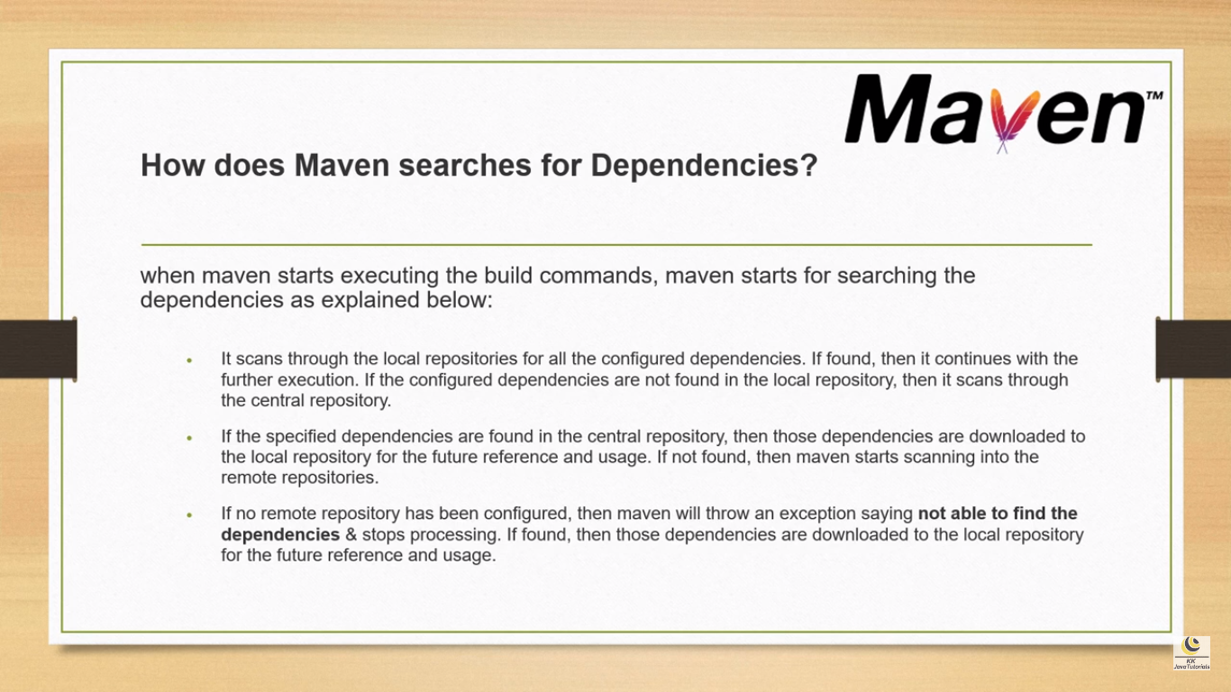

# Part – 11 : Understanding of Maven Dependency Scopes



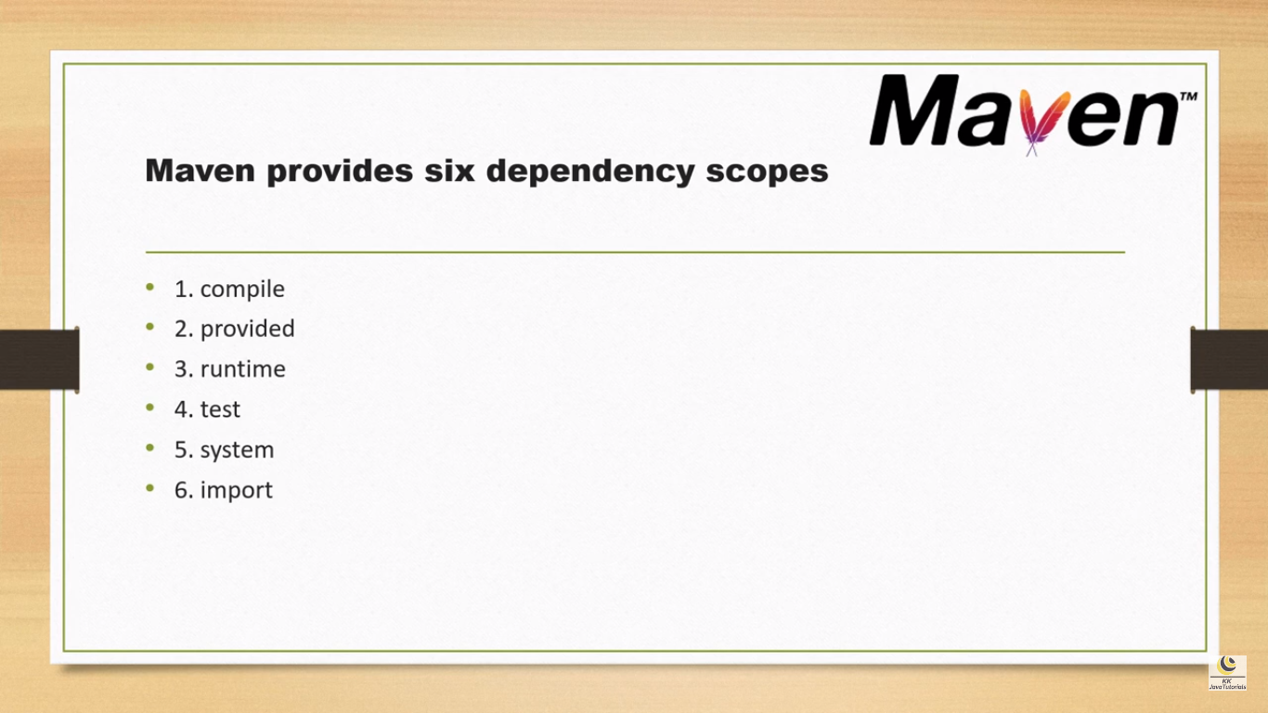

Refer this below url for complete reference

<https://www.baeldung.com/maven-dependency-scopes>

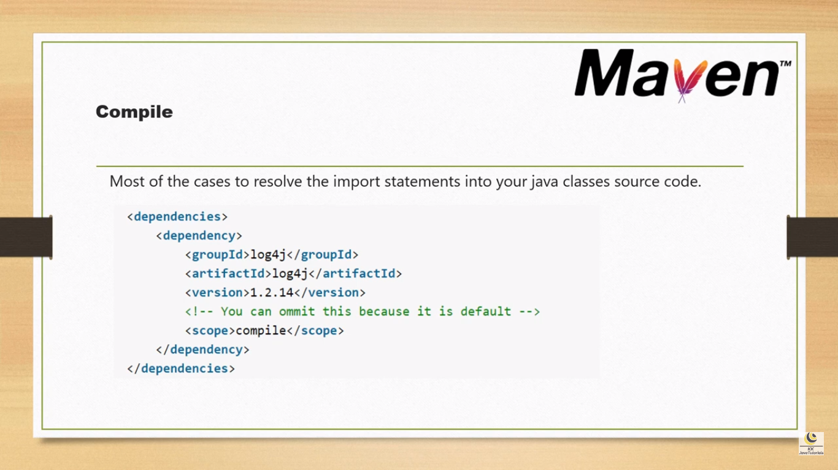

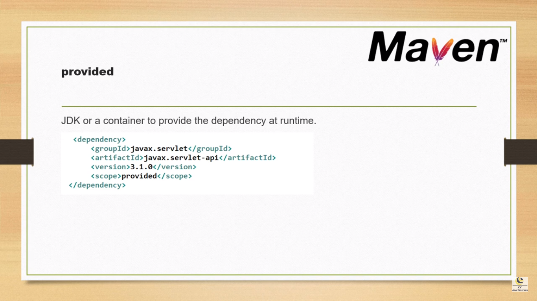

Provided : We use this scope to mark **dependencies that should be provided at runtime by JDK or a container.**

A good use case for this scope would be a web application deployed in some container, where the container already provides some libraries itself. For example, this could be a web server that already provides the Servlet API at runtime.

In our project, we can define those dependencies with the provided scope:

<**dependency**>

<**groupId**>javax.servlet</**groupId**>

<**artifactId**>javax.servlet-api</**artifactId**>

<**version**>4.0.1</**version**>

<**scope**>provided</**scope**>

</**dependency**>

The *provided*dependencies are available only at compile time and in the test classpath of the project. These dependencies are also not transitive.

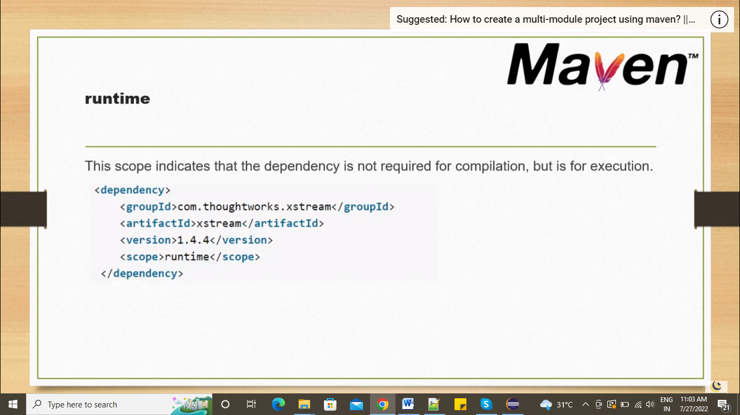

### ****Runtime****

**The dependencies with this scope are required at runtime.** But we don't need them for the compilation of the project code. Because of that, dependencies marked with the runtime scope will be present in the runtime and test classpath, but they will be missing from the compile classpath.

A JDBC driver is a good example of dependencies that should use the runtime scope:

<**dependency**>

<**groupId**>mysql</**groupId**>

<**artifactId**>mysql-connector-java</**artifactId**>

<**version**>8.0.28</**version**>

<**scope**>runtime</**scope**>

</**dependency**>

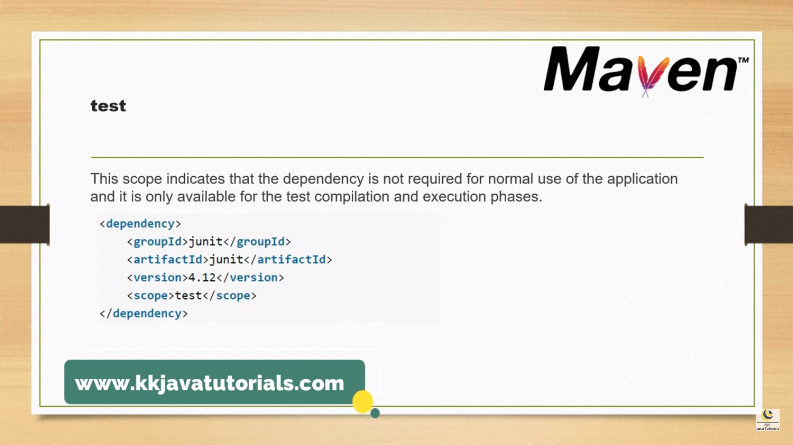

**Test dependencies aren't transitive and are only present for test and execution classpaths.**

The standard use case for this scope is adding a test library such as JUnit to our application

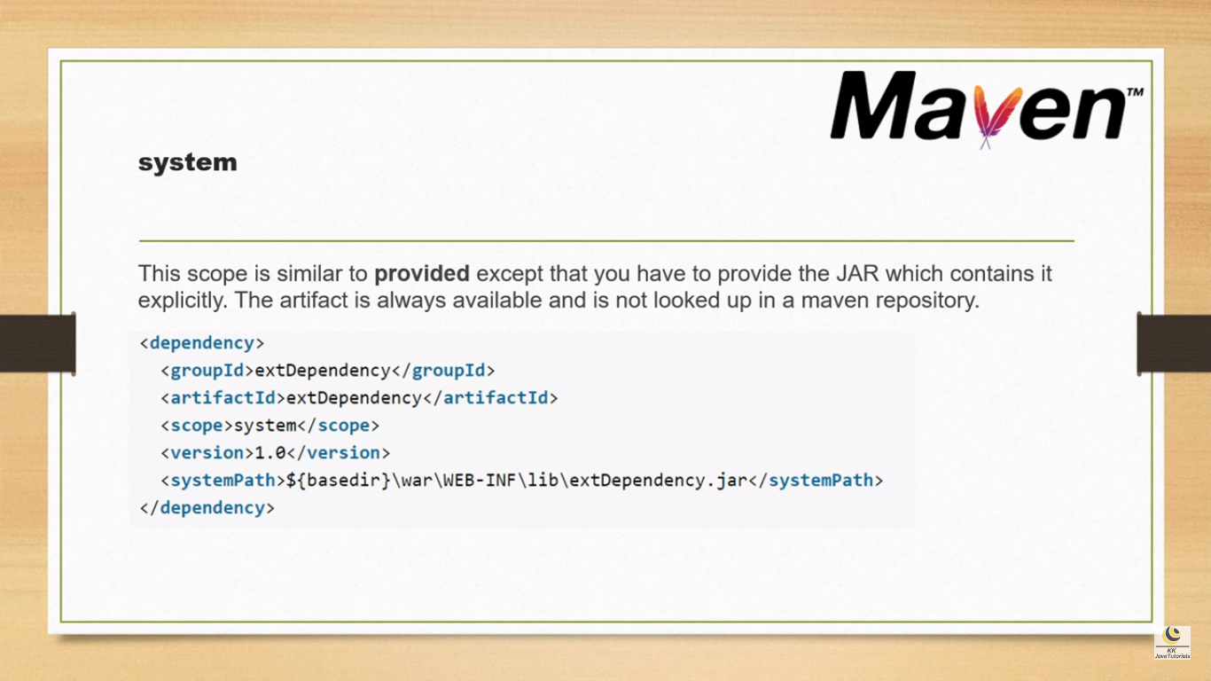

### ****System****

**System scope is very similar to the provided scope.** The main difference is that system requires us to directly point to a specific jar on the system.

It's worthwhile to mention that [**system scope is deprecated**](https://maven.apache.org/guides/introduction/introduction-to-dependency-mechanism.html#system-dependencies)**.**

The important thing to remember is that building the project with system scope dependencies may fail on different machines if dependencies aren't present or are located in a different place than the one systemPath points to:

<**dependency**>

<**groupId**>com.baeldung</**groupId**>

<**artifactId**>custom-dependency</**artifactId**>

<**version**>1.3.2</**version**>

<**scope**>system</**scope**>

<**systemPath**>${project.basedir}/libs/custom-dependency-1.3.2.jar</**systemPath**>

</**dependency**>

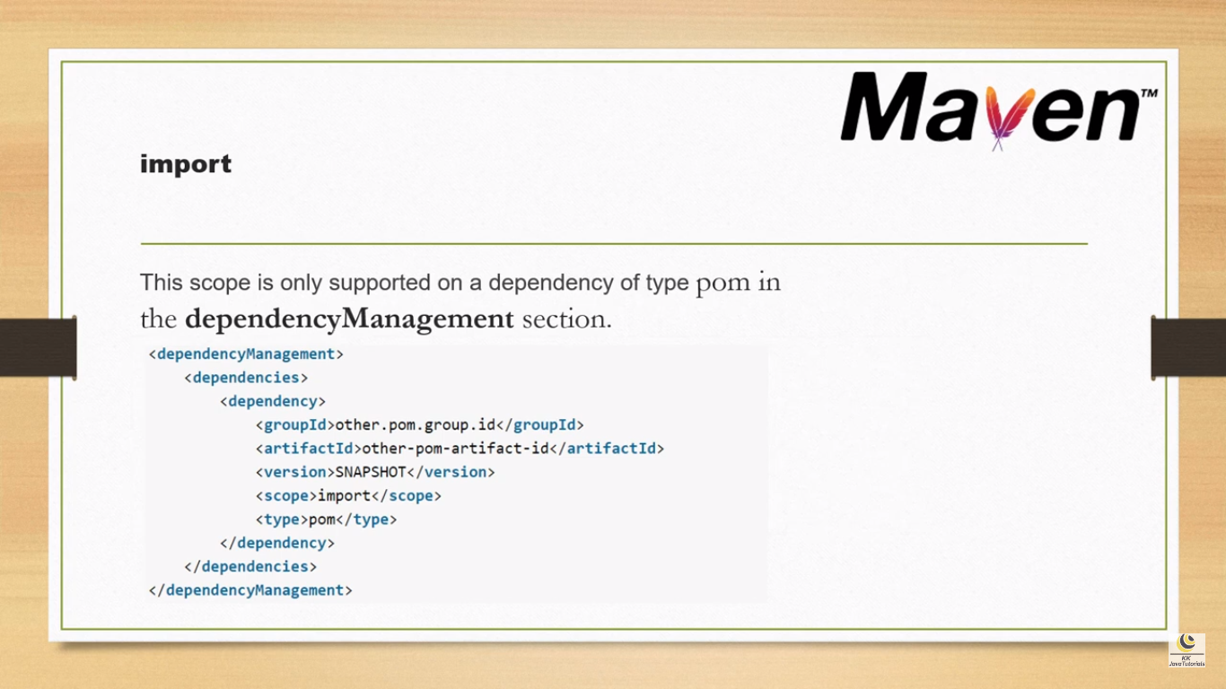

### ****Import****

**It's only available for the dependency type pom.**

import indicates that this dependency should be replaced with all effective dependencies declared in its POM.

Here, below custom-project dependency will be replaced with all dependencies declared in custom-project's pom.xml <dependencyManagement> section.

<**dependency**>

<**groupId**>com.baeldung</**groupId**>

<**artifactId**>custom-project</**artifactId**>

<**version**>1.3.2</**version**>

<**type**>pom</**type**>

<**scope**>import</**scope**>

</**dependency**>

# Part – 14 : How to create user defined properties in Maven

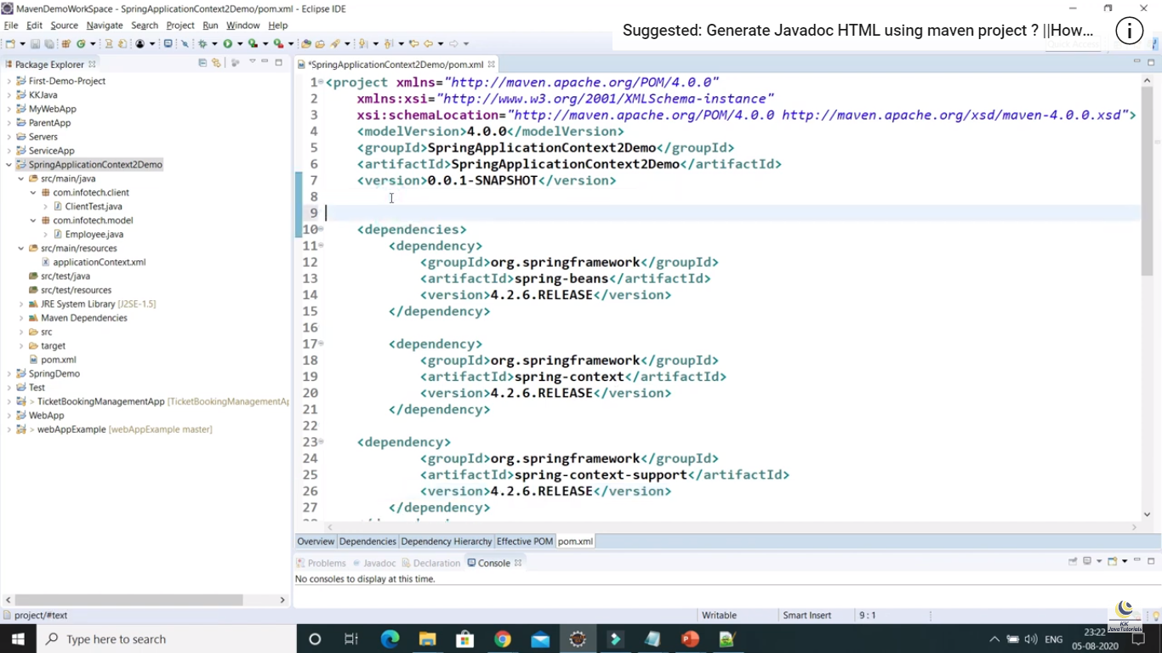

# Part – 15 : Maven Dependency Exclusion

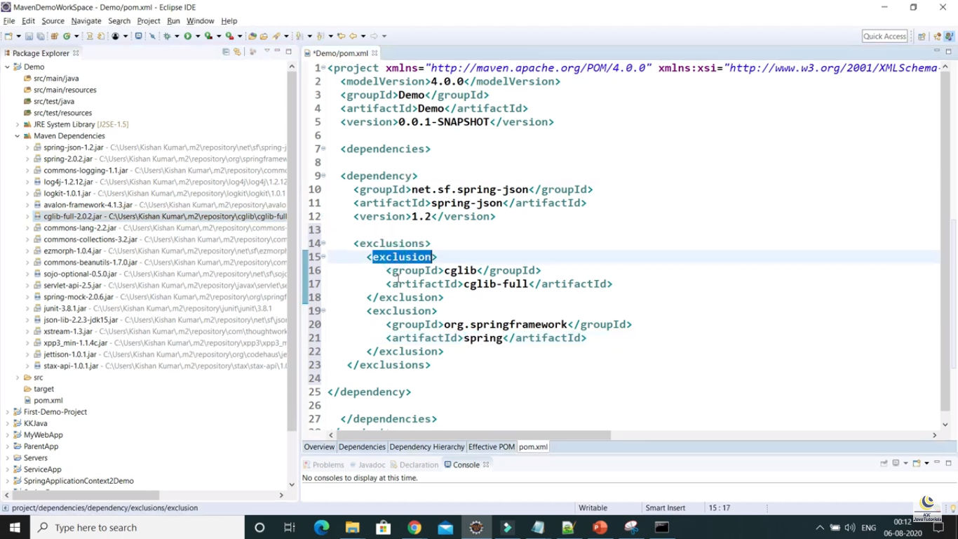

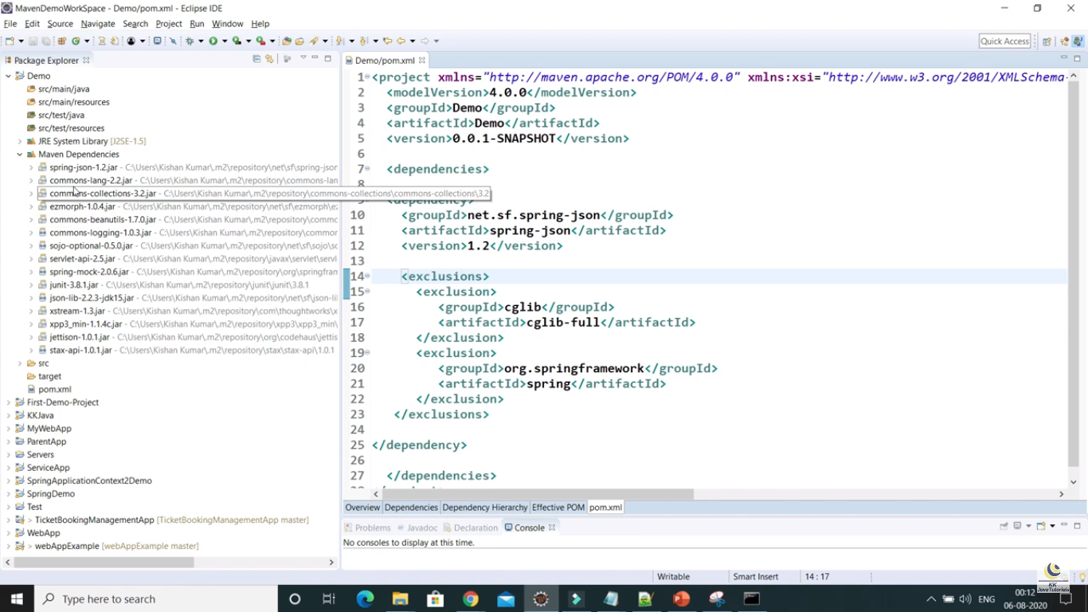

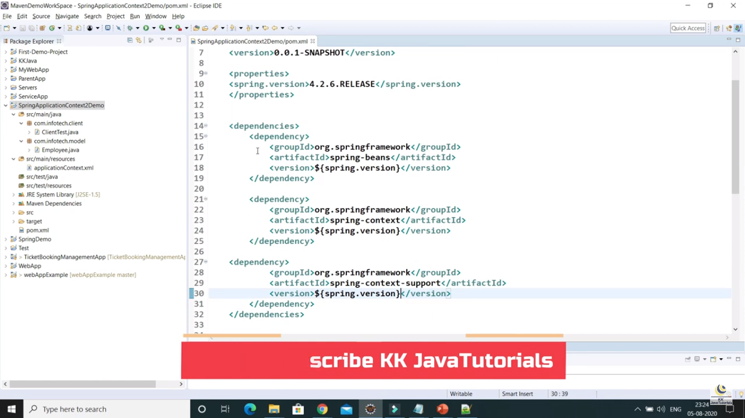

# Part – 25 : Understanding of settings.xml in Maven

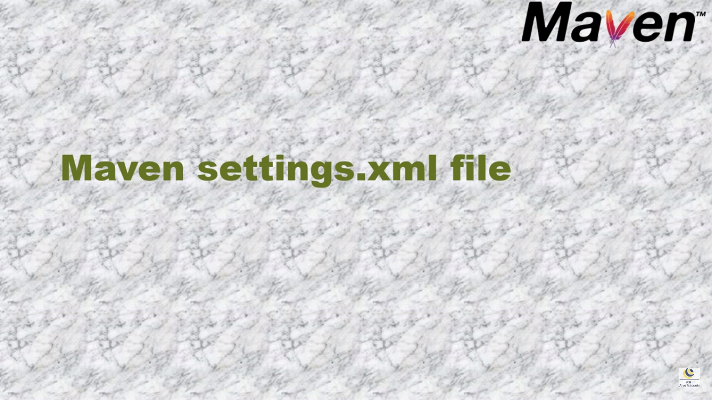

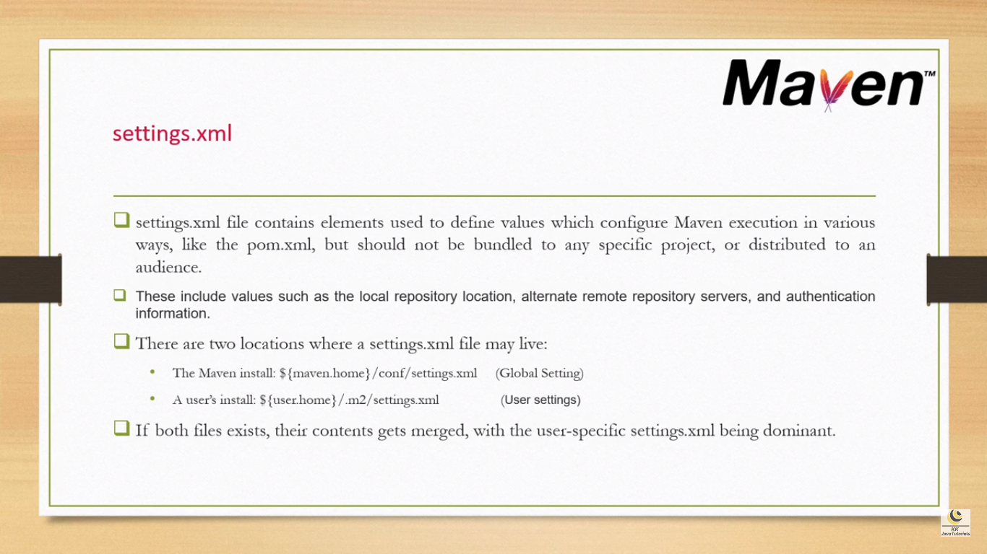

# Part – 28: How to set filename of package generated by maven

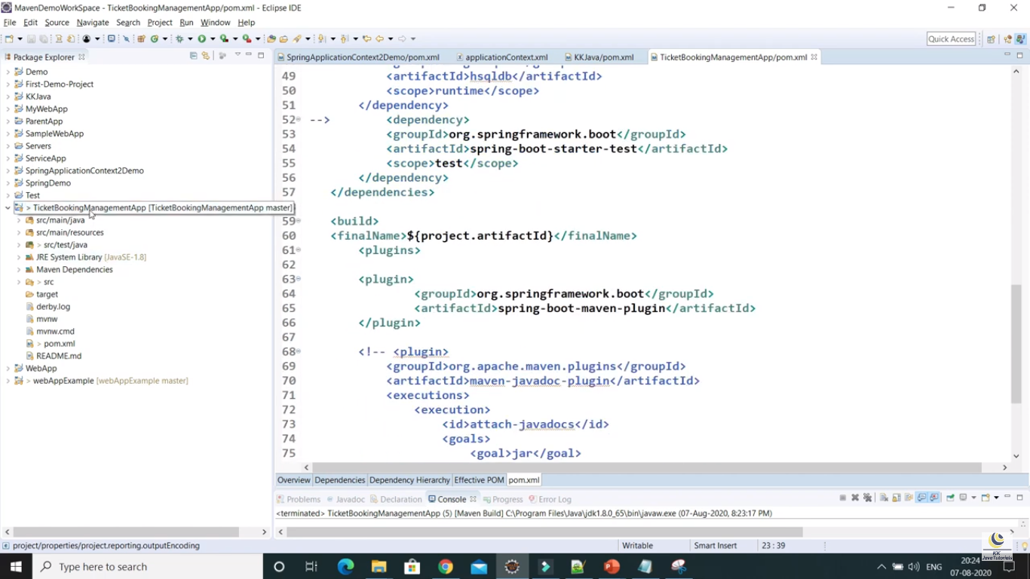

# Part – 17 How to Fix missing src/main/java & src/test/java folders in Eclipse Maven web Project ?

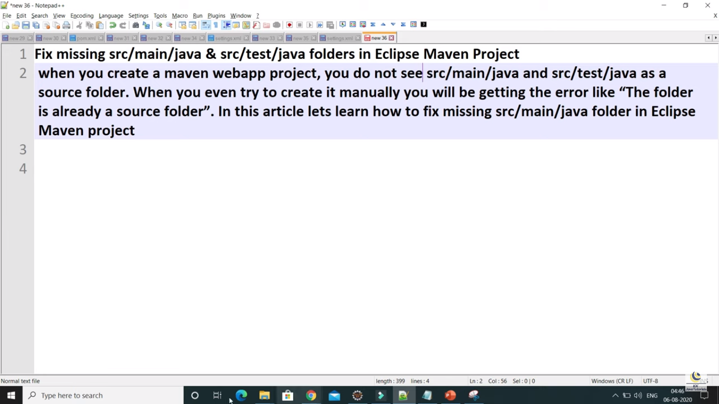

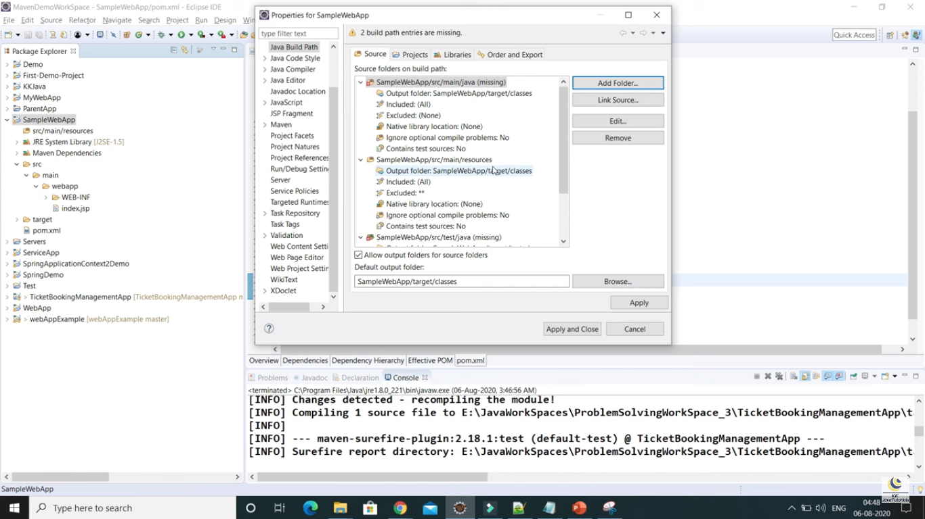

This issue is related to JDK, So we need to change the jdk

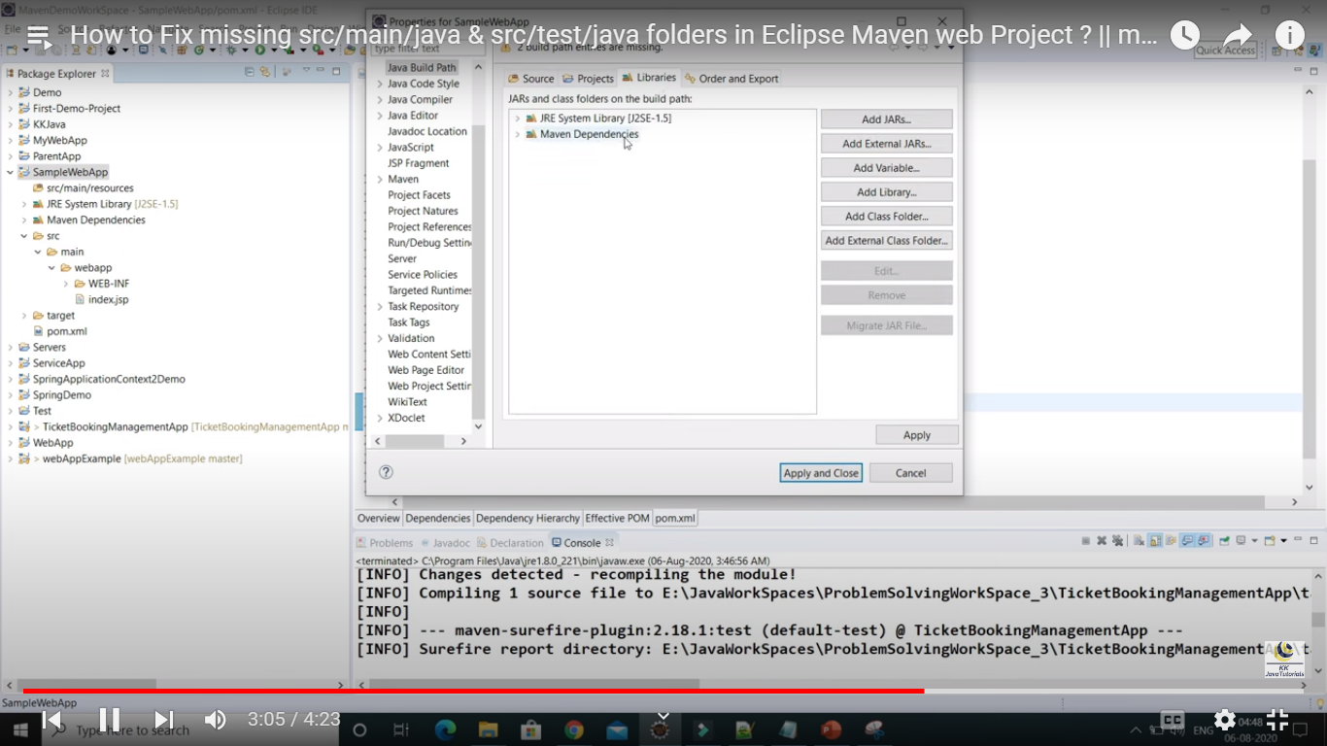

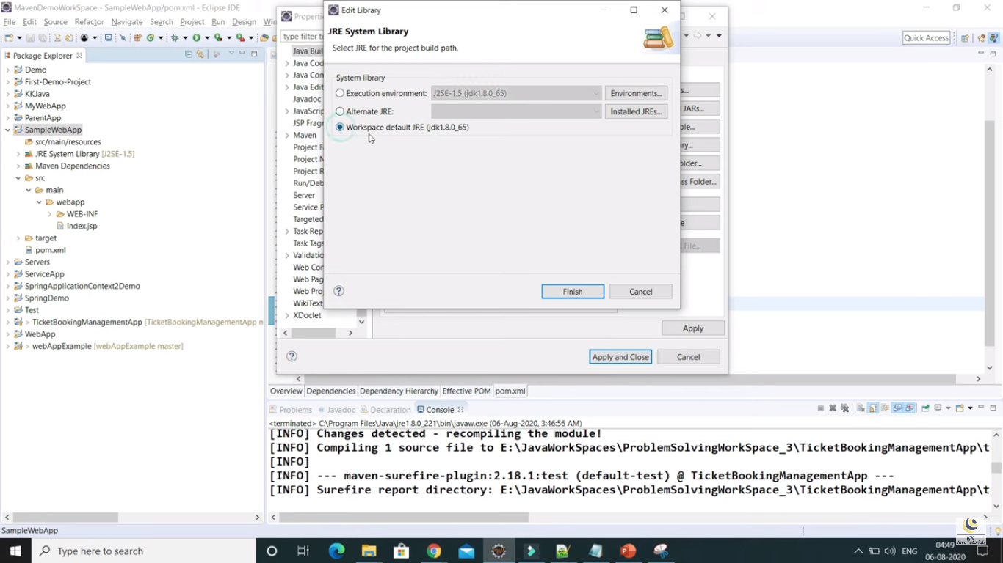

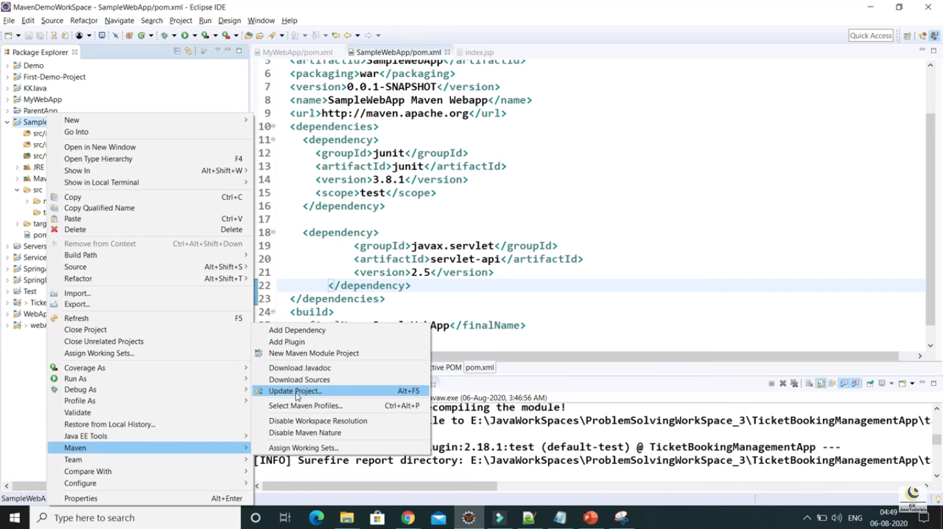

# Part – 18 How to Import Maven Remote Archetype Catalogs in Eclipse ?

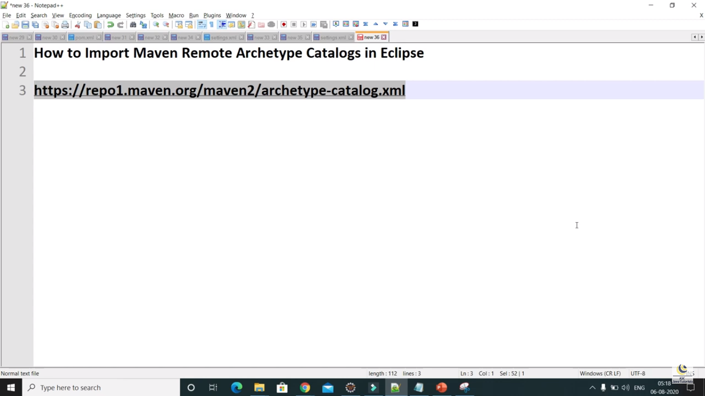

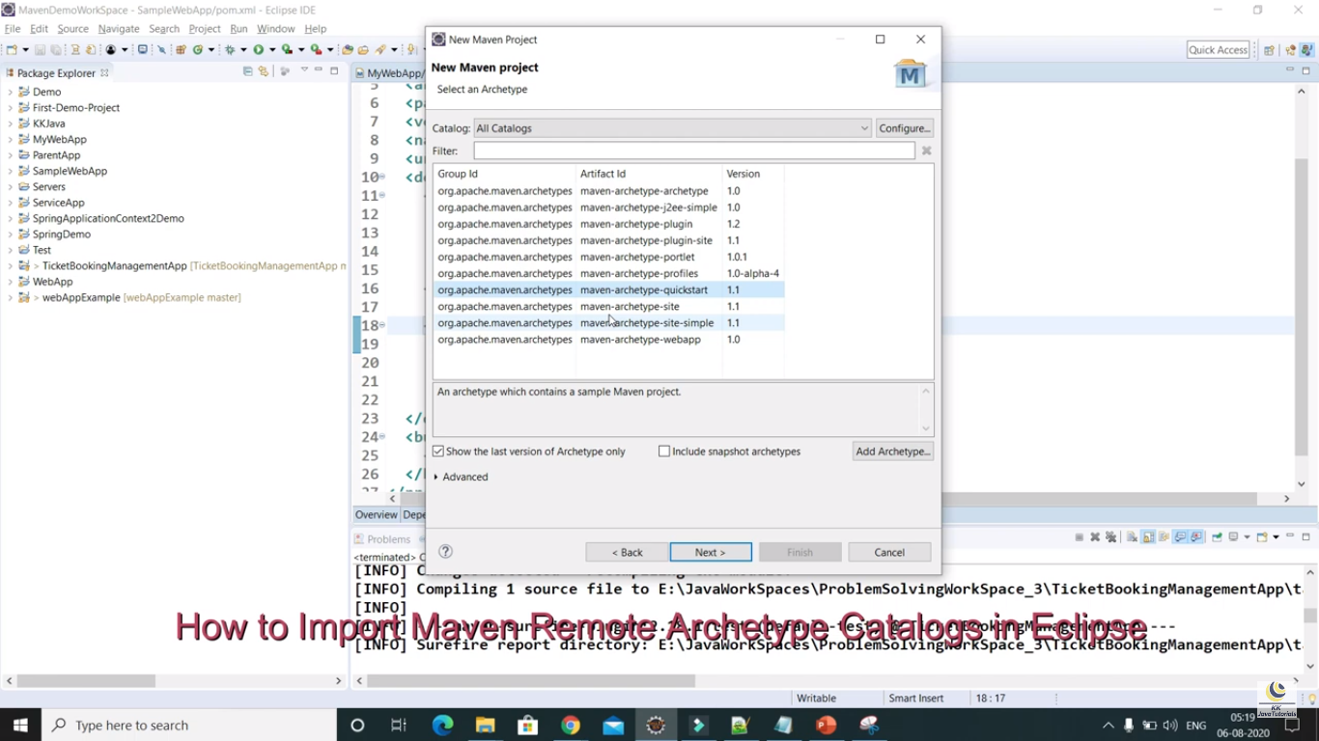

Here in the above screen shot, only limited archetypes are there, So how to update this

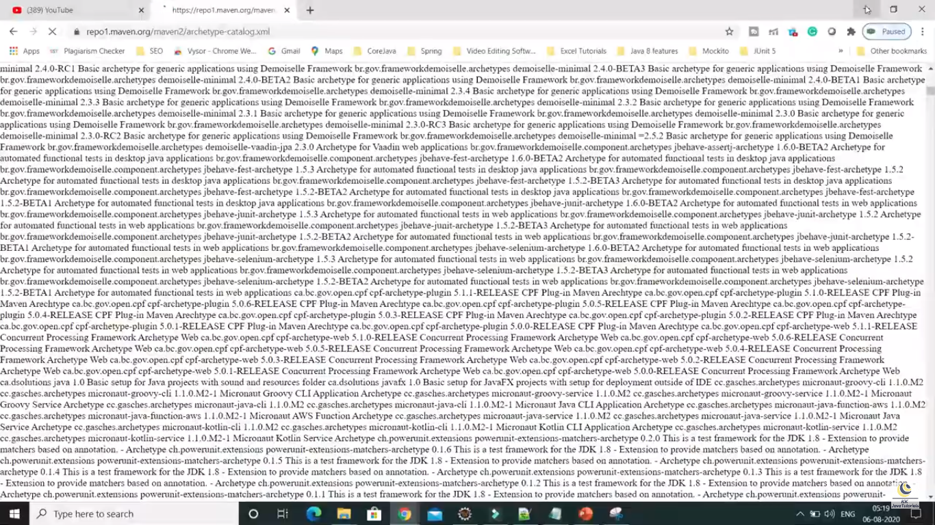

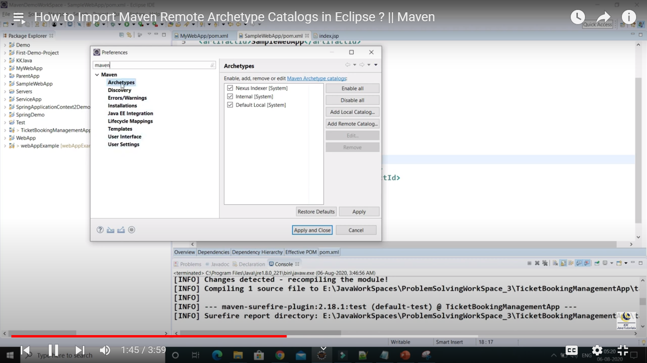

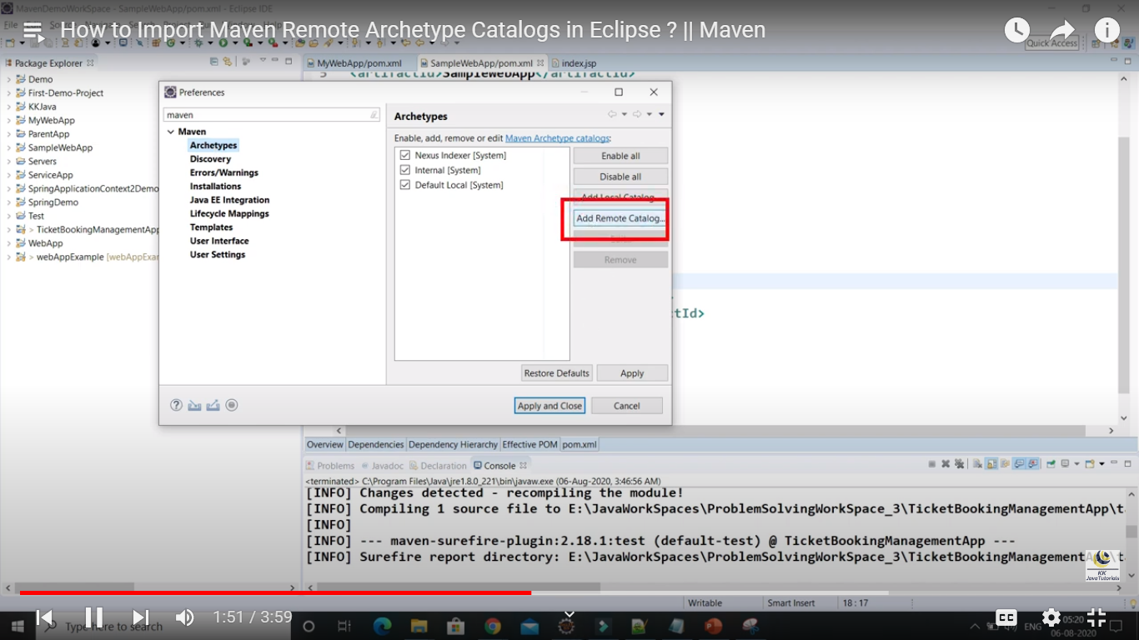

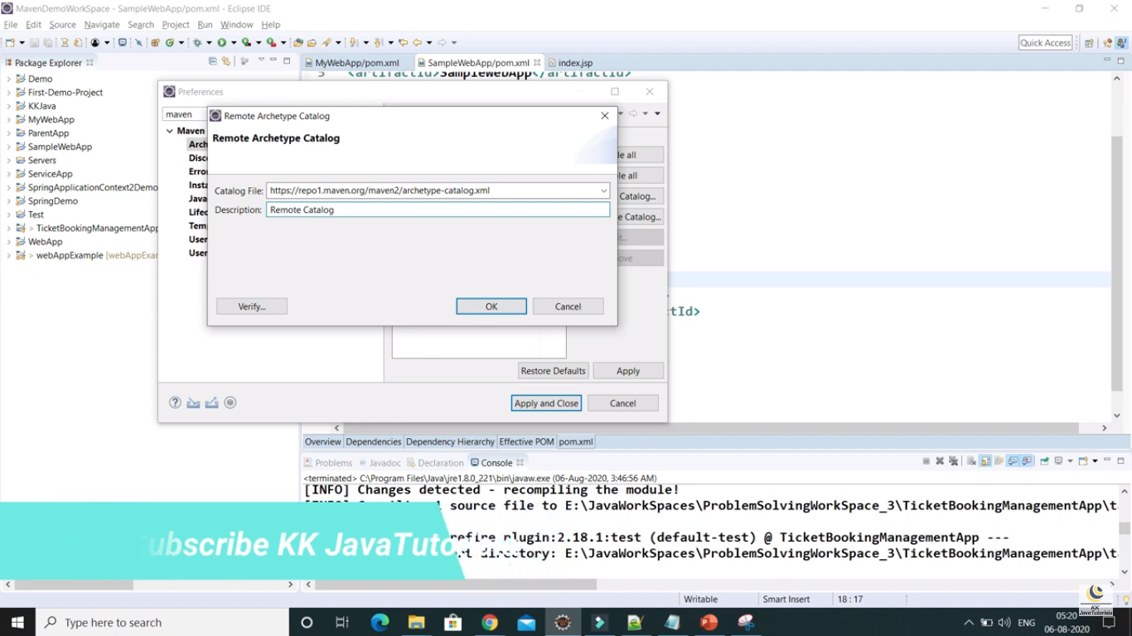

# Part – 22 What is an archetype in Maven?



